

Exploring Options for Actively Cooling the Earth Programme Thesis
v2.0
Author Mark Symes, Programme Director go to his ARIA page by following http://www.aria.org.uk/what-were-working-on/#mark

CONTEXT
This document presents the core thesis underpinning a programme that has now launched.

See the programme page at https://www.aria.org.uk/exploring-climate-cooling/ or sign up for all updates about this opportunity space at https://www.aria.org.uk/opportunity-space-updates/

Sign up at https://www.aria.org.uk/opportunity-space-updates/ to receive all updates about this opportunity space and see the programme at http://www.aria.org.uk/exploring-climate-cooling

An ARIA programme seeks to unlock a scientific or technical capability that

- changes the perception of what’s possible or valuable
- has the potential to catalyse massive social and economic returns
- is unlikely to be achieved without ARIA’s intervention.

UPDATE: OUR THINKING, EVOLVED
A summary capturing the evolution of our thinking since first publication.

This programme thesis is derived from the ARIA opportunity space: https://www.aria.org.uk/wp-content/uploads/2023/12/ARIA-managing-our-climate-and-weather-through-responsible-engineering-v1.0.pdf. The original version of the thesis was published in May 2024 and has been updated following community feedback. To read the original version of the thesis please see here. The main changes to the thesis are:

- More detail has been provided on the governance of outdoor experiments, including an outdoor experiment funding approval decision tree. An outline of the roles and responsibilities of the independent programme oversight committee is also provided in a separate https://www.aria.org.uk/wp-content/uploads/2024/09/Exploring-Climate-Cooling-Programme-Oversight-and-Governance.pdf?
- A section on why ARIA is leading this research effort has been added, together with some thoughts around how international collaboration and cooperation in this space could be catalysed.
- Some of the language has been clarified to better reflect the intended purpose and scale of the research that ARIA will support.

PROGRAMME THESIS, SIMPLY STATED
This programme thesis is derived from the ARIA opportunity space: which can be accessed here https://www.aria.org.uk/wp-content/uploads/2023/12/ARIA-managing-our-climate-and-weather-through-responsible-engineering-v1.0.pdf

Climate change, largely caused by anthropogenic greenhouse gas emissions, could cause the global temperature to increase by several degrees by the end of the century, precipitating climate tipping points with serious consequences. The solution to this problem is to cease the burning of fossil fuels and to eliminate excess greenhouse gases from the atmosphere. However, lowering atmospheric greenhouse gas levels – even under the most aggressive scenarios – may not happen fast enough to prevent the onset of tipping points.

Such reasoning has led to proposals for methods to actively cool the Earth in order to “buy time” to decarbonise, and there has been considerable debate around the risks and benefits of these various methods. However, in the absence of substantial physical (as opposed to simulated) data on the mechanisms behind how these concepts might work (and what their effects might be), there is no prospect of being able to make proper judgements on what are or are not feasible, scalable, and controllable approaches for cooling the Earth.

This programme aims to answer fundamental questions as to the practicality, measurability, controllability and possible (side-)effects of such approaches through indoor and (where necessary) small, controlled, outdoor experiments. In answering these questions, we plan to fund not only the experiments themselves, but also the necessary modelling, simulation, observation and monitoring required to support the experiments, as well as research into the ethical, governance, law, and geopolitical dimensions of the approaches under investigation. Our objective is that the information gathered by this programme will allow for more definitive assessments on whether one or more of the approaches examined may one day be used responsibly and ethically to delay or avert the onset of temperature-induced climate tipping points.

PROGRAMME THESIS, EXPLAINED
A detailed description of the programme thesis, presented for constructive feedback

Why this programme

Risk vs. risk

The Intergovernmental Panel on Climate Change (IPCC) has noted that global warming in excess of 1.5 °C above pre-industrial levels is now likely, even if increased action allows the world to achieve net zero emissions by 2040 [1]. Furthermore, it has stated that “the pace and scale of what has been done so far, and current plans, are insufficient to tackle climate change.” [2] In this context, there is increasing debate as to whether society should (and whether it can) buy time to decarbonise by manipulating certain variables to reduce global temperatures on a short-to-medium term basis.

This comes against a background of concern around the potential for climate tipping points (abrupt alterations in the Earth’s climate system), which may lead to essentially irreversible disruptive changes on a regional or global scale if the global temperature exceeds certain thresholds for any length of time [3,4]. Examples of such tipping points include the melting of the Arctic winter sea ice (leading to accelerated warming via ice-albedo feedback [5]), dieback of the Amazon rainforest and consequent ecosystem loss, and collapse of the major land-based ice sheets, leading to significant global sea level rises.

The thresholds for many such tipping points remain far from clear, but it seems likely that a certain amount of continued global warming is already locked in, even with rapid decarbonisation, on account of the amount of carbon dioxide already in the atmosphere [6,7]. The practical difficulties of rapid decarbonisation also imply that further warming will occur [8]. In this context, approaches such as stratospheric aerosol injection [9], marine cloud brightening [10], increasing the reflectivity of the Earth’s surface (e.g. by re-growing ice sheets) [11], and constructing space-based reflectors to shade the Earth from a proportion of incoming sunlight [12] have been proposed as potential methods by which to cool the Earth whilst sufficient carbon dioxide is removed from the atmosphere to bring global temperatures down.

However, many poorly-constrained risks associated with the approaches above currently exist, especially regarding the scope and scale of their side-effects — which may affect different parts of the world unevenly [13]. Concerns also exist related to moral hazard [14], and the extent to which developing the capability to lower global temperatures without lowering atmospheric greenhouse gas levels (i.e. “treating the symptoms, but not the disease”) reduces the incentive to reach net zero and/or remove carbon dioxide from the atmosphere in a timely manner.

How (or whether) research into methods that could be used to reduce global temperatures should be conducted throws up a number of open questions [15-17]. For example, do the risks of unintended consequences and moral hazard associated with learning more about Earth-cooling approaches outweigh the risks of continued global warming without researching any intervention strategies? How should we weigh the risks associated with researching approaches for reducing global temperatures against the risk that the world discovers in 2040 or 2050 that efforts to achieve net zero and to remove carbon dioxide from the atmosphere have been insufficient to prevent very detrimental tipping points [18]? In such a scenario, what might be the risks of hurried deployment of under-researched climate engineering approaches where we have little understanding of the consequences? And if these approaches were deployed, what might be the risks associated with a later, more sudden deployment relative to a slower ramp-up? Or the risks of termination shocks if deployment were suddenly stopped [19]?

Questions like these have fuelled a debate that has been ongoing for years [20], but which remains unresolvable with our current level of understanding. After considerable deliberation on the balance of risks, ARIA has come to the view that the risks of not being able to answer such questions are greater than the risks of researching approaches for actively cooling the Earth through a well-governed research programme. Others have come to similar conclusions regarding the need for research in this area to be undertaken transparently and in the public interest [21, 22]. It is in this context that ARIA has chosen to pursue a research programme into approaches for actively cooling the Earth.

Our discovery process has suggested to us that a key barrier to advancing our understanding of this field and being able to reach more definitive conclusions on particular approaches is a comparative dearth of real and relevant physical data from outdoor experiments [23-25]. Hence, we see a need for a programme that will accommodate small, controlled, geographically-confined outdoor experiments on approaches that may one day scale to help reduce global temperatures. These outdoor experiments are intended to answer critical scientific questions as to the practicality, measurability, controllability and likely (side-)effects of the proposed approaches that cannot be answered by other means. They may not be necessary or possible for all the projects we fund, and they are not meant to be stepping stones to deployment. To support the outdoor experiments, we plan to fund activities ranging from modelling and simulation, through to in-field observation and monitoring, and research on the legal, ethical, governance and geopolitical dimensions of the approaches under study.

The research conducted in this programme should allow us to provide critical (and currently missing) real-world data to scientists and society on what the options are for actively cooling the Earth, how such approaches might work, and what the consequences of their use might be, allowing better-informed assessments of their risks and benefits. Successful outcomes from this programme include ruling particular options out from further study as technically infeasible, ruling them out as infeasible due to risks that cannot be adequately constrained, or highlighting which approaches show promise and would benefit from further research and development.

Our approach

Our approach will be to develop a scientific framework to underpin strong predict → test → monitor → validate loops for a range of approaches (Figure 1). The “predict”, “monitor” and “societal aspects” nodes in Figure 1 have received some (although arguably insufficient) interest in recent years. However, research into how approaches for cooling the Earth might work in practice, how their effects would be demonstrated with statistical confidence, and how any resulting technology might be scaled effectively has received much less attention. Therefore, whilst further research across all of the areas shown in Figure 1 is vital, we see that the “test” and “validate” nodes are particularly underserved.

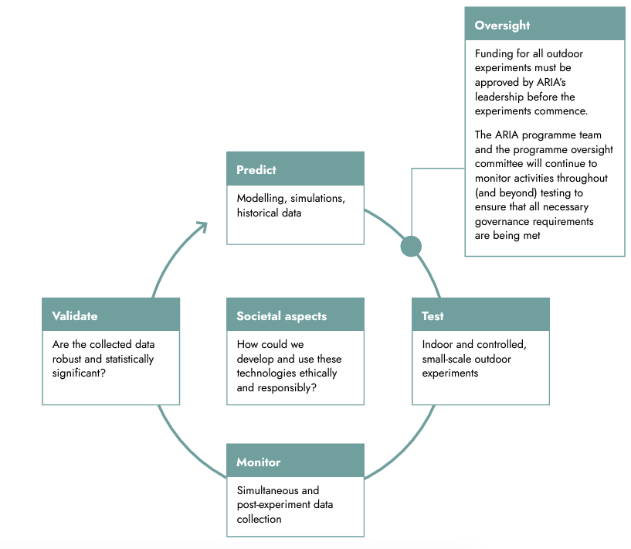

Figure 1: A technology research loop showing the “predict”, “test”, “monitor”, “validate” and “societal aspects” nodes. Details on the oversight mechanisms are described herein and in the separate programme oversight and governance document.

Computer modelling and the indoor testing of approaches are essential and necessary first steps in establishing the basic science behind how (or whether) a particular approach might work. However, modelling and indoor testing alone cannot provide all the data necessary to predict the effects of a given approach in the real world with a suitable level of confidence. Controlled outdoor experiments are therefore likely to be required to truly advance our understanding of the phenomena underlying potential approaches. Initial thoughts on how outdoor experiments in this programme could be conducted openly and responsibly are presented throughout this thesis for constructive feedback, with the aim that these form the basis for decisions on whether any given outdoor test could proceed and how such experiments could be conducted responsibly.

A suggested framework for outdoor experiments
There is the potential for unintended negative consequences in any outdoor experiment. Therefore, it will be important to define transparently and at the outset a set of principles that can guide the programme’s consideration of whether and how outdoor testing can proceed. ARIA has incorporated lessons from previous projects where outdoor experiments have been cancelled before commencing [26-29] and those where outdoor experiments have gone ahead [30,11] in developing these principles, with the aim of supporting the development of best practices for safe and transparent outdoor experiments.

Our guiding principle for outdoor experiments is that these should be conducted on the smallest possible length and timescales required to validate, with statistical confidence, that the approaches being tested can affect the parameters under investigation. These scales will be approach-specific; however, Appendix A posits what the upper bounds for the scale and duration of an outdoor experiment could be. In all cases, we expect initial outdoor tests to occur at much smaller scales than these upper bounds (for example, an appropriate scale for an initial outdoor cloud brightening experiment might be on the order of a few hundred metres).

The magnitude of the intended perturbation should be limited so that it is within the bounds of known and benign natural phenomena (or anthropogenic phenomena that are considered harmless), so that there is precedent for the size of the effect that will be produced. The experiments should be designed so that as far as possible the effects either dissipate through natural mechanisms within hours, or can be localised with very high certainty, or else that there should be an obvious and reliable mechanism for switching off the effect at any time, on demand. These features should minimise the risks of negative unintended consequences by confining the effects in space and/or time. A combination of considerations on the size, duration and reversibility of outdoor experiments leads to the following suggested decision tree for assessing whether a particular outdoor experiment might be supported through this programme (Figure 2).
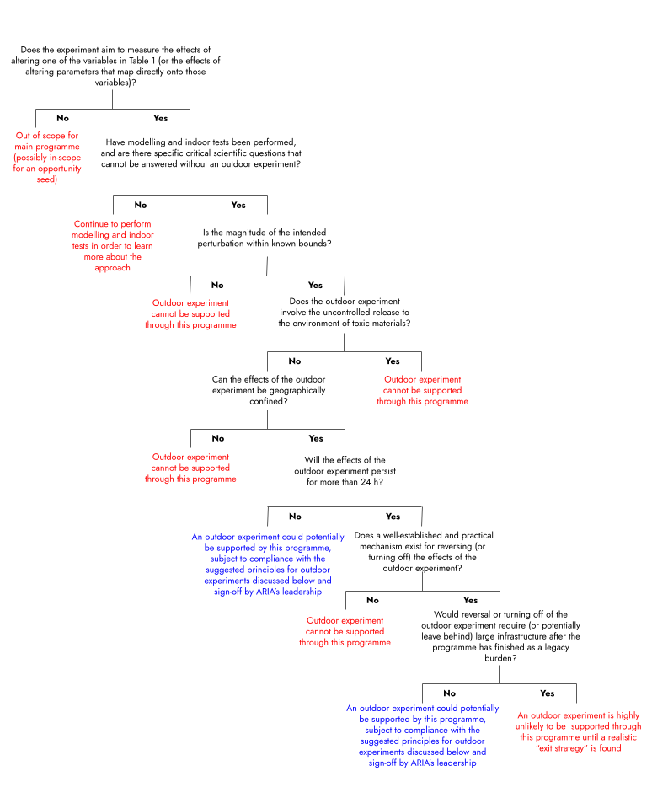
Figure 2: A suggested outdoor experiment technical consideration decision tree, to be used in conjunction with the principles for outdoor experiment oversight described in the main text. Please refer to Table 1 under What will projects need to demonstrate? For a description of the relevant variables.

The suggestion is that applicants proposing outdoor experiments use this decision tree at the application stage in order to see if their intended experiment could in theory be supported by this programme or not.

In addition to this basic technical information, the following suggested principles for oversight of any subsequent outdoor experiments are presented here for feedback:

- ARIA will not fund experiments where the activities proposed are prohibited by domestic or international law. Project teams will be required to show how their tests comply with all applicable laws.
- A risk assessment will be performed and the findings made publicly available before any outdoor experiment. This will be conducted by experts who are independent of the team performing the experiment, and will include relevant potential technological, environmental and socio-economic risks.
- Minimising risk by design. Outdoor experiments should be designed at the minimum viable scale required for the generation of robust data, and where the magnitude of any perturbation has a natural analogue or commonly accepted anthropogenic precedent (and therefore where the effect of the perturbation is within the range of known and benign phenomena). Such considerations are summarised in Figure 2.
- Transparency, public participation and consultation. Wherever possible, those conducting outdoor experiments will be required to notify and consult those who could reasonably be considered as likely to be affected by the experiments. ARIA sees consultation and engagement with the public as processes that will be sustained for the lifetime of projects. To facilitate informed decision making, detailed plans for the outdoor experiments, and the key decisions taken in developing these plans, will be consulted upon as transparently as possible well in advance of any experiment. The specific protocols for transparency will be developed in consultation with the Oversight Committee, and will include provisions for transparency regarding what the experiments involve, why the experiments are necessary, who is conducting the experiments, and who might be impacted by the experiments. The results of the experiments (including negative results) will also be made publicly available in an accessible form.
- Independent impact assessment. Post-experiment, the environmental and any socio-economic impacts will be assessed by experts who are independent of the team performing the outdoor experiments, and the results of these assessments will be made publicly available. ARIA may also commission assessments of the broader implications of the experiments as appropriate.
- Limited scope. Activities in this programme will be limited to research scale – ARIA will not fund deployment or any demonstration beyond the approved experiments.

These principles then underpin the following outdoor experiment funding approval decision tree (Figure 3), which describes our current thinking on the steps that project teams will need to take in order for funding for a particular outdoor experiment (or series of linked experiments) to be approved. We expect that ARIA will provide specialist support to assist project teams in undertaking these activities.

ARIA’s leadership will be ultimately responsible for governance, oversight and the release of funding for outdoor experiments, leveraging input from an independent programme oversight committee. ARIA also has a Committee of the Board for ethics and social responsibility, which has visibility across all of ARIA’s programmes.

Find out more about the independent programme oversight committee and its relationship to other actors in the programme by going to this link https://www.aria.org.uk/wp-content/uploads/2024/09/Exploring-Climate-Cooling-Programme-Oversight-and-Governance.pdf?

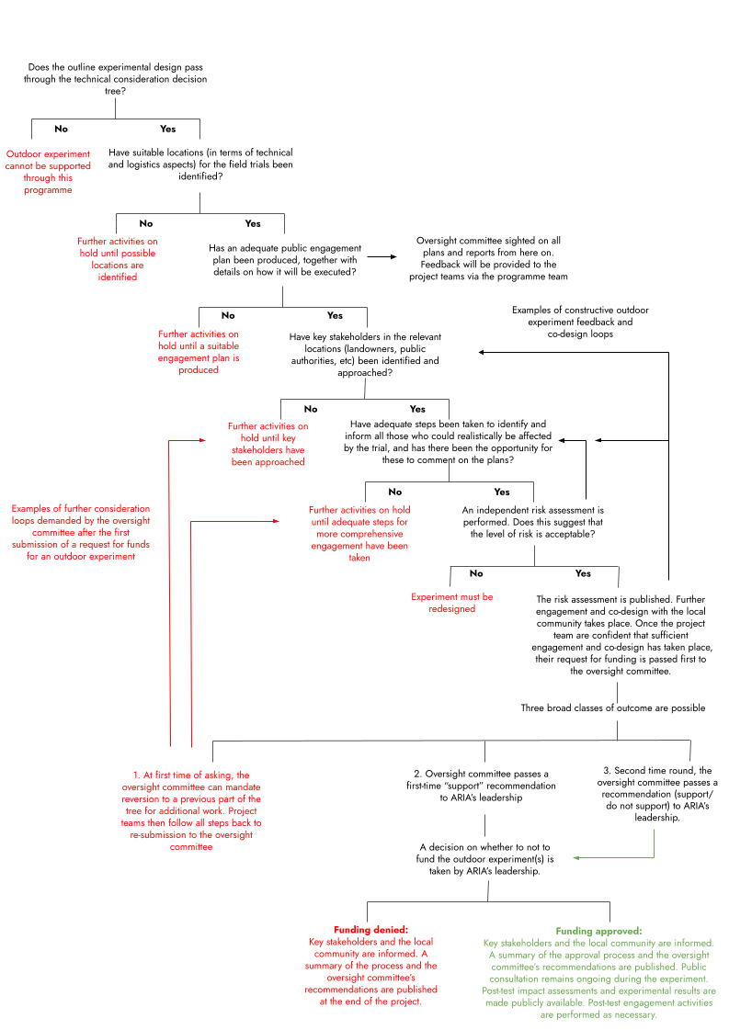

Figure 3: A suggested outdoor experiment funding approval decision tree.

A key aim is to earn and maintain trust in the research that is being undertaken. This will be underpinned by a culture of transparency. Our aim is to establish a culture of complete openness for outdoor experiments in terms of what activities are undertaken and their outcomes, similar to that which the International Civil Aviation Organization champions for the sharing of best practices in the aviation industry [31]. The principles above are designed to embed this mindset from the beginning of the R&D pathway for the approaches supported by this programme.

International partnerships with other funding organisations

The impacts of climate tipping points (and the effects of actively cooling the Earth to delay or avoid the onset of these) are likely to be felt globally. Therefore, we contend that it is vital that public institutions lead research into approaches for actively cooling the Earth, acting in a spirit of open international collaboration and cooperation, with full transparency, for the benefit of the global community [32].

By funding research into both the technical and non-technical aspects of approaches for actively cooling the Earth, this programme aims to drive forward both fundamental understanding of these approaches and their risks, and the development of structures for just and informed deliberation on their benefits and risks in lockstep.

Responsible and transparent research into actively cooling the Earth - including what the impacts of these approaches might be, and how their use might be governed - will require an international effort, led by public institutions. To aid international cooperation, ARIA intends to:

- Fund projects and researchers globally as part of this programme

- Bring an open mindset to co-funding projects with other government funding agencies

- Make ourselves and our expert networks available to other government and (potentially other public benefit) funding agencies which are considering establishing their own research programmes in this space, including support with validation and verification of experiments

- Create opportunities for sharing best practice and learning with representatives of international and public benefit funding agencies, including annual workshops and invitations to observe the outdoor experiments that we fund

- Upon invitation, send expert teams from ARIA, or within its network, to observe and feed back on experiments being funded by other government funding agencies

- Consider requests from other government funding agencies (both UK and non-UK) to observe the workings of the ARIA programme’s oversight committee.

Through these routes for promoting international participation in the programme, sharing best practice, and building a culture of transparent cooperation for governing small-scale research experiments, we aim to start building up the expertise, ways of working, and critical mass and diversity of practitioners that a future international governance body would find immensely useful. To further these aims, ARIA commits to being fully transparent across our programme design, management, and disclosure of the results of the research that is funded, by:

- Requiring that the results from the work that we fund (including negative results) are available in a publicly available, open-access form, unless such publication would be likely to lead to public harm.

- Making supporting documentation related to our outdoor experiments publicly available on the ARIA website (including pre-experiment risk assessments, post-experiment impact assessments, recommendations from our oversight committee, and results from our public engagement and co-design activities)

- Continuing to update and iterate our (publicly available) governance and oversight procedures, explaining why any changes are being made.

What we expect to fund

Funding across silos
We anticipate supporting research into approaches for reducing global temperatures across the entire range of science and engineering disciplines. We also expect to support projects across the social sciences, arts, humanities, and law/policy research that are of direct relevance to those approaches (including, but by no means limited to, consideration of public perception; design of potential legal, ethical, regulatory and governance frameworks; and the economic or broader social impacts of those approaches). We have also set aside funding to support project teams in working through specific aspects of ethics and community engagement, as well as documenting lessons that may be more broadly applicable for other research programmes.

ARIA is aware of previous and ongoing initiatives that have considered some of the ethical and societal issues around governance, stakeholder engagement and perceptions related to approaches for actively cooling the Earth over the last few years (see, for example: [33-36]). ARIA aims to provide as much flexibility as possible in terms of how the social sciences and humanities are represented in this programme. For example, ARIA may fund social scientists, ethicists, legal scholars, or humanities researchers to work specifically on certain technical research teams. In addition, ARIA may also fund a dedicated social science, law, and governance strand that works across the full range of approaches under investigation, in a manner that complements the efforts of social scientists that are embedded in specific research teams.

What will projects need to demonstrate?
The overarching goal of this programme is to answer the most critical technical and fundamental questions on the practicality, measurability, controllability, and likely (side-)effects of approaches that might one day be used to actively cool the Earth. Projects will therefore need to demonstrate how they align with this goal.

A very simplified estimate of the equilibrium temperature at the Earth’s surface (T_{surf}) is provided by the equation below [37]:

$T_{surf} =\sqrt[4]{\frac{S(1-α)}{2σ(2-ε)}}$

Where S is the solar constant (the power per unit area impinging on the Earth from solar irradiation), ɑ is the planetary albedo (a measure of how much short-wave radiation is reflected from the Earth without being absorbed), 𝜎 is the Stefan-Boltzmann constant, and 𝜀 is the effective emissivity of the atmosphere (𝜎 and 𝜀 together give a measure of how much long-wave radiation is emitted by the Earth back out to space).

In order to be in-scope for this programme, projects will need to demonstrate how the research they are proposing meets at least one of the following criteria:
- The approaches being researched have the potential to alter T_{surf} (at any scale) by affecting at least one of the variables ɑ, ε or S (see Table 1) in a manner that is statistically distinguishable from the background
- The approaches being researched have the potential to alter parameters that map directly onto the variables ɑ, ε or S (applicants will be required to justify explicitly how the parameters being perturbed map onto ɑ, ε or S) in a manner that is statistically distinguishable from the background
- The research proposed has direct bearing on the prediction, modelling, measurement, monitoring, validation, governance, education, public perception, ethics or other research questions related to approaches or experiments that could alter at least one of the variables ɑ, ε or S (or parameters that map directly onto those variables)
- The research proposed has direct bearing on open questions or uncertainties about the ecological or other environmental impacts, risks or side-effects related to approaches or experiments that could alter at least one of the variables ɑ, ε or S (or parameters that map directly onto those variables).

ARIA encourages research plans that build in careful attention to measuring possible unintended side-effects and understanding possible risks. Where physical experiments are being proposed, applicants will need to consider testability and statistical significance in their proposals (for example, can any parallels or lessons be drawn from some of the ways in which statistical methods have been employed to evaluate field trials of cloud seeding [38-40]?). For physical experiments, project teams will need to convince the reviewers as to why the measurements/perturbations that they intend to make are the right things to measure/perturb, and how the results would substantially advance the validation or invalidation of the approach on the grounds of practicality, scalability, safety or impacts. ARIA will require publication of the results of the work that we fund (including negative results) in an accessible form, except if their publication would be likely to lead to public harm.

Table 1: Variables for study in this programme. The examples of approaches that could address these variables are not exhaustive, and neither should they be construed as use cases that ARIA considers to be more or less valuable than any others that can be imagined.

Variable | Examples of approaches that could address this variable (non exhaustive)
Planetary albedo (ɑ) | Marine cloud brightening [10]; ice sheet thickening [41]
Effective solar constant (S) | Space-based reflectors [12]
Effective emissivity of the atmosphere (𝜀) | Cirrus cloud thinning [42,43]

Programme differentiation
To date, there have been very few actual (or even attempted) outdoor experiments into approaches whose ultimate goal would be to reduce global or regional temperatures on a short-to-medium term basis. We are not aware of any other programmes that have funded outdoor experiments with multiple different approaches in a coordinated way. Indeed, to date, all outdoor experiments that have been attempted or conducted in this space have been undertaken as individual stand-alone projects. This means that these projects have therefore also struggled to cover all of the nodes represented in Figure 1 comprehensively.

This programme has a strong emphasis on statistical significance and on understanding the physical principles that underlie the effects that the various approaches may produce. In this context, even if the only outcome of the programme is to prove that all the approaches that are investigated are either infeasible at scale or produce effects that are indistinguishable from natural background processes, then we will consider this a success. Such an outcome would directly support our objective to allow better-informed assessments as to whether any of the approaches examined may one day be used responsibly and ethically to reduce global temperatures on a short-to-medium term basis. This approach and outcome agnosticism strongly differentiates this programme.

Programme scope

Table 2 gives a breakdown of areas that we expect to be out of scope for this programme, along with the reasoning we have taken in coming to these decisions. Approaches that are not explicitly listed as out of scope will be considered (provided that their specific intent relates to the controlled perturbation of one of the variables given in Table 1, or altering parameters that map directly onto those variables). Opportunity seed funding may subsequently be available to support individuals or teams pursuing ambitious research that is out of scope for the programme, but which falls within the scope of the wider opportunity space Future Proofing Our Climate and Weather.

Table 2: Out of scope areas for this programme

Topic or activity | Reasoning and comments
Removal, sequestration and/or utilisation of carbon dioxide | Multiple other public and private funders are already funding carbon dioxide removal and utilisation
General weather/climate simulation or monitoring activities that do not provide insights into the effects of altering one of the variables in Table 1 (or parameters that map directly onto those variables). | Only simulation or monitoring activities that could be relevant to the temperature-reducing approaches being researched in this programme will be in scope. This programme is distinct from the work of the Natural Environment Research Council and their Research programme to model the impact of solar radiation management which can be found at this link https://www.ukri.org/news/research-programme-to-model-impact-of-solar-radiation-management/ [44], and has been developed independently. ARIA will continue to engage with NERC as development of both programmes progresses.
Outdoor experiments where analysis via Figure 2 indicates that such experiments cannot be supported by this programme | Outdoor experiments that Figure 2 indicates cannot be supported will not be funded through this programme
Large-scale trials of climate engineering technologies continuously or over extended durations | This programme will only fund activities at research scale

Our approach to results and IP for this programme

We are pursuing a very open approach to intellectual property (IP). Work under this programme should be undertaken with the intention of making project outcomes open-source and freely available. This means that the results from the work that we fund (including negative results) should be made available in a publicly available, open-access form, unless such publication would be likely to lead to public harm. As part of this, project teams will be required to give as much detail as possible on methodology and experimental data to ensure openness and transparency.

Intellectual property created by projects funded as part of this programme shall be published under creative commons or open source licences as appropriate. Our default position will be that project teams will not be permitted to file for patents in respect of inventions resulting from work that has been funded as part of this programme. We’ll be asking all successful applicants and their team members to sign a public pledge not to seek patents on any work that is funded by this programme. This approach is designed to enhance the public good by maximising the accessibility, usability, and collaborative potential of the funded projects, ensuring that the benefits extend to a wider community and fostering a culture of open innovation.

SOURCES
References cited in this document.

[1] “Mitigation Pathways Compatible with 1.5°C in the Context of Sustainable Development,” Cambridge University Press, 2022, p. 93174. doi: https://doi.org/10.1017/9781009157940.004.

[2] IPCC, “Urgent Climate Action Can Secure a Liveable Future for All — IPCC,” IPCC, Mar. 20, 2023. https://www.ipcc.ch/2023/03/20/press-release-ar6-synthesis-report.

[3] D. I. Armstrong McKay et al., “Exceeding 1.5°C global warming could trigger multiple climate tipping points,” Science, vol. 377, no. 6611, Sep. 2022, doi: https://doi.org/10.1126/science.abn7950.

[4] P. D. L. Ritchie, J. J. Clarke, P. M. Cox, and C. Huntingford, “Overshooting tipping point thresholds in a changing climate,” Nature, vol. 592, no. 7855, pp. 517–523, Apr. 2021, doi: https://doi.org/10.1038/s41586-021-03263-2 .

[5] H. Kashiwase, K. I. Ohshima, S. Nihashi, and H. Eicken, “Evidence for ice-ocean albedo feedback in the Arctic Ocean shifting to a seasonal ice zone,” Scientific Reports, vol. 7, no. 1, Aug. 2017, doi: https://doi.org/10.1038/s41598-017-08467-z.

[6] K. L. Ricke and K. Caldeira, “Maximum warming occurs about one decade after a carbon dioxide emission,” Environmental Research Letters, vol. 9, no. 12, p. 124002, Dec. 2014, doi: https://doi.org/10.1088/1748-9326/9/12/124002.

[7] K. Zickfeld and T. Herrington, “The time lag between a carbon dioxide emission and maximum warming increases with the size of the emission,” Environmental Research Letters, vol. 10, no. 3, p. 031001, Mar. 2015, doi: https://doi.org/10.1088/1748-9326/10/3/031001.

[8] J. F. Abrams et al., “Committed Global Warming Risks Triggering Multiple Climate Tipping Points,” Earth’s Future, vol. 11, no. 11, Nov. 2023, doi: https://doi.org/10.1029/2022ef003250.

[9] E. Brody et al., “Kicking the Can Down the Road: Understanding the Effects of Delaying the Deployment of Stratospheric Aerosol Injection,” arXiv (Cornell University), Feb. 2024, doi: https://doi.org/10.48550/arxiv.2402.11992.

[10] H. Hirasawa, D. Hingmire, H. A. Singh, P. J. Rasch, and P. Mitra, “Effect of Regional Marine Cloud Brightening Interventions on Climate Tipping Elements,” Geophysical Research Letters, vol. 50, no. 20, Oct. 2023, doi: https://doi.org/10.1029/2023gl104314.

[11] “HOME,” Real Ice. https://www.realice.eco/

[12] I. Szapudi, “Solar radiation management with a tethered sun shield,” Proceedings of the National Academy of Sciences of the United States of America, vol. 120, no. 32, p. e2307434120, Aug. 2023, doi: https://doi.org/10.1073/pnas.2307434120.

[13] K. L. Ricke, M. G. Morgan, and M. R. Allen, “Regional climate response to solar-radiation management,” Nature Geoscience, vol. 3, no. 8, pp. 537–541, Jul. 2010, doi: https://doi.org/10.1038/ngeo915.

[14] D. McLaren, “Mitigation deterrence and the ‘moral hazard’ of solar radiation management,” Earth’s Future, vol. 4, no. 12, pp. 596–602, Dec. 2016, doi: https://doi.org/10.1002/2016ef000445.

[15] P. C. Frumhoff and J. C. Stephens, “Towards legitimacy of the solar geoengineering research enterprise,” Philosophical Transactions of the Royal Society A: Mathematical, Physical and Engineering Sciences, vol. 376, no. 2119, p. 20160459, Apr. 2018, doi: https://doi.org/10.1098/rsta.2016.0459.

[16] B. Kravitz and D. G. MacMartin, “Uncertainty and the basis for confidence in solar geoengineering research,” Nature Reviews Earth & Environment, vol. 1, no. 1, pp. 64–75, Jan. 2020, doi: https://doi.org/10.1038/s43017-019-0004-7.

[17] D. McLaren and O. Corry, “The politics and governance of research into solar geoengineering,” WIREs Climate Change, vol. 12, no. 3, Mar. 2021, doi: https://doi.org/10.1002/wcc.707.

[18] T. Felgenhauer, M. Brune, J. Wiener, and J. Xu, “Solar Radiation Modification: A Risk-Risk Analysis Carnegie Climate Governance Initiative An initiative of,” 2022. Available: https://www.c2g2.net/wp-content/uploads/202203-C2G-RR-Full.pdf

[19] A. Parker and P. J. Irvine, “The Risk of Termination Shock From Solar Geoengineering,” Earth’s Future, vol. 6, no. 3, pp. 456–467, Mar. 2018, doi: https://doi.org/10.1002/2017ef000735.

[20] “Geoengineering the climate: science, governance and uncertainty,” The Royal Society, royalsociety.org, Sep. 2009. https://royalsociety.org/-/media/policy/publications/2009/8693.pdf

[21] C. Wieners et al., “Solar Radiation Modification is risky, but so is rejecting it: A call for balanced research,” Oxford open climate change, Mar. 2023, doi: https://doi.org/10.1093/oxfclm/kgad002.

[22] H. J. Buck and S. Nicholson, “Solar geoengineering research in the global public interest: A proposal for how to do it,” One Earth, vol. 6, no. 12, pp. 1652–1664, Dec. 2023, doi: https://doi.org/10.1016/j.oneear.2023.11.012.

[23] D. W. Keith, E. Parson, and M. G. Morgan, “Research on global sun block needed now,” Nature, vol. 463, no. 7280, pp. 426–427, Jan. 2010, doi: https://doi.org/10.1038/463426a.

[24] D. W. Keith, R. Duren, and D. G. MacMartin, “Field experiments on solar geoengineering: report of a workshop exploring a representative research portfolio,” Philosophical Transactions of the Royal Society A: Mathematical, Physical and Engineering Sciences, vol. 372, no. 2031, p. 20140175, Dec. 2014, doi: https://doi.org/10.1098/rsta.2014.0175.

[25] G. Feingold et al., “Physical science research needed to evaluate the viability and risks of marine cloud brightening,” Science Advances, vol. 10, no. 12, Mar. 2024, doi: https://doi.org/10.1126/sciadv.adi8594.

[26] “The SPICE Project | SPICE,” http://www.spice.ac.uk.

[27] J. Stilgoe, M. Watson, and K. Kuo, “Public Engagement with Biotechnologies Offers Lessons for the Governance of Geoengineering Research and Beyond,” PLoS Biology, vol. 11, no. 11, p. e1001707, Nov. 2013, doi: https://doi.org/10.1371/journal.pbio.1001707.

[28] “Keutsch Group at Harvard - SCoPEx,” https://www.keutschgroup.com/scopex.

[29] “Final Report - SCoPEx Advisory Committee,” SCoPEx Advisory Committee, Mar. 17, 2024. https://scopexac.com/finalreport/

[30] “What is marine cloud brightening?,” Great Barrier Reef Foundation. https://www.barrierreef.org/news/explainers/what-is-cloud-brightening.

[31] ICAO, “Safety,” Icao.int, 2024. https://www.icao.int/safety/Pages/default.aspx

[32] “Solar Radiation Modification: Governance gaps and challenges,” 2022. Available: https://www.c2g2.net/wp-content/uploads/202203-C2G-GovGaps.pdf

[33] “European Transdisciplinary Assessment of Climate Engineering (EuTRACE) | Research Institute for Sustainability,” https://www.rifs-potsdam.de/en/research/eutrace

[34] “C2G | Carnegie Climate Governance Initiative,” C2G. https://www.c2g2.net/solar-radiation-modification.

[35] “CO-CREATE,” EIEE - European Institute on Economics and the Environment. https://www.eiee.org/project/co-create

[36] N. Zuniga, “Degrees launches world’s first research fund for SRM social science in the Global South,” The DEGREES Initiative, Oct. 25, 2023. https://www.degrees.ngo/degrees-launches-worlds-first-research-fund-for-srm-social-science-in-the-global-south

[37] J. A. Coakley Jr. and P. Yang, Atmospheric Radiation: A Primer with Illustrative Solutions. Wiley, 2014, p. Chapter 6, 185-201. Available: https://www.wiley.com/en-gb/Atmospheric+Radiation:+A+Primer+with+Illustrative+Solutions-p-9783527410989.

[38] W. L. Woodley and D. Rosenfeld, “The Development and Testing of a New Method to Evaluate the Operational Cloud-Seeding Programs in Texas,” vol. 43, no. 2, pp. 249–263, Feb. 2004, doi: https://doi.org/10.1175/1520-0450(2004)043%3C0249:tdatoa%3E2.0.co;2.

[39] D. Breed, R. Rasmussen, C. Weeks, B. Boe, and T. Deshler, “Evaluating Winter Orographic Cloud Seeding: Design of the Wyoming Weather Modification Pilot Project (WWMPP),” Journal of Applied Meteorology and Climatology, vol. 53, no. 2, pp. 282–299, Feb. 2014, doi: https://doi.org/10.1175/jamc-d-13-0128.1.

[40] X. Wu et al., “Advances in the Evaluation of Cloud Seeding: Statistical Evidence for the Enhancement of Precipitation,” Earth and Space Science, vol. 5, no. 9, pp. 425–439, Sep. 2018, doi: https://doi.org/10.1029/2018ea000424.

[41] R. Minunno, N. Andersson, and G. M. Morrison, “A systematic literature review considering the implementation of planetary geoengineering techniques for the mitigation of sea-level rise,” Earth-Science Reviews, vol. 241, p. 104431, Jun. 2023, doi: https://doi.org/10.1016/j.earscirev.2023.104431.

[42] D. L. Mitchell and W. Finnegan, “Modification of cirrus clouds to reduce global warming,” Environmental Research Letters, vol. 4, no. 4, p. 045102, Oct. 2009, doi: https://doi.org/10.1088/1748-9326/4/4/045102.

[43] C. Tully, D. Neubauer, D. Villanueva, and U. Lohmann, “Does prognostic seeding along flight tracks produce the desired effects of cirrus cloud thinning?,” Atmospheric Chemistry and Physics, vol. 23, no. 13, pp. 7673–7698, Jul. 2023, doi: https://doi.org/10.5194/acp-23-7673-2023.

[44] “Research programme to model impact of solar radiation management,” www.ukri.org, Feb. 28, 2024. https://www.ukri.org/news/research-programme-to-model-impact-of-solar-radiation-management (accessed Apr. 25, 2024).

[45] G. W. Platzman, “The Rossby wave,” The Quarterly Journal of the Royal Meteorological Society , vol. 94, no. 401, pp. 225–248, Jul. 1968, doi: https://doi.org/10.1002/qj.49709440102.

[46] D. R. Durran and M. Gingrich, “Atmospheric Predictability: Why Butterflies Are Not of Practical Importance,” Journal of the Atmospheric Sciences, vol. 71, no. 7, pp. 2476–2488, Jun. 2014, doi: https://doi.org/10.1175/jas-d-14-0007.1.

[47] P. A. Durkee et al., “Composite Ship Track Characteristics,” Journal Of The Atmospheric Sciences, vol. 57, no. 16, pp. 2542–2553, Aug. 2000, doi: https://doi.org/10.1175/1520-0469(2000)057%3C2542:cstc%3E2.0.co;2.

[48] P. Manshausen, D. Watson-Parris, M. W. Christensen, J.-P. Jalkanen, and P. Stier, “Invisible ship tracks show large cloud sensitivity to aerosol,” Nature, vol. 610, no. 7930, pp. 101–106, Oct. 2022, doi: https://doi.org/10.1038/s41586-022-05122-0.

[49] D. Watson-Parris, M. W. Christensen, A. Laurenson, D. Clewley, E. Gryspeerdt, and P. Stier, “Shipping regulations lead to large reduction in cloud perturbations,” Proceedings of the National Academy of Sciences of the United States of America, vol. 119, no. 41, Oct. 2022, doi: https://doi.
org/10.1073/pnas.2206885119.

APPENDIX A: Initial analysis on outdoor experiment scale
Rossby waves [45] caused by the Earth's rotation define characteristic length scales for weather systems in the UK that are on the order of 1000 km. Work examining the impact that perturbations in weather models have on the predictability of atmospheric conditions suggests that very large perturbations (by up to 100%) can be made on a length scale of 10 km without any significant effect on the behaviour of the overall system (at 1000 km scale) [46]. Therefore, a maximum outdoor experiment grid parameter on the order of 10 km should be small enough that any perturbation caused in that space for short periods (e.g. 24 hours or less) will subsequently be dwarfed by natural chaotic processes operating at larger scales once the experiment has ended. However, proposers will be required to start with outdoor experiments smaller than this (especially for initial tests) in order to demonstrate safety and controllability. Likewise, ARIA strongly prefers outdoor experiments in areas remote from population centres. Such scales place these outdoor experiments and their effects in the range of “microscale meteorology”, as distinct from both the larger weather systems that we are familiar with from weather forecasts and the climate at large (see Figure 5).

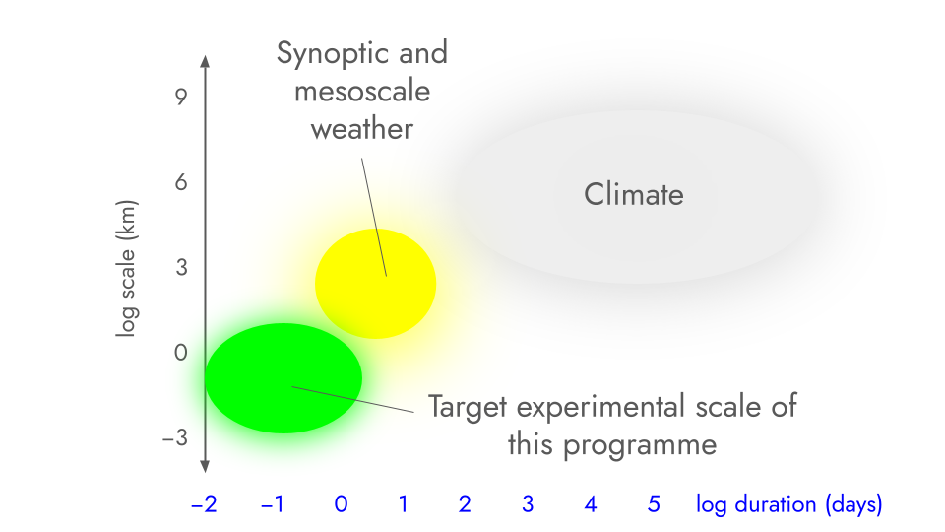

Figure 5: Context on the suggested scale and duration of outdoor experiments that could be accommodated in this programme. The figure shows the difference between the scale and duration of the climate, weather and target experiments for the programme both area and duration are on log scales.

These suggested length and timescale upper bounds are commensurate with (or indeed smaller than) those previously employed in anthropogenic climate perturbation experiments. Two examples are provided. Firstly, the marine cloud brightening project operating on the Great Barrier Reef [30] generates a plume behind the vessel that can grow in extent to 10-20 km, with effects that dissipate within hours. Secondly, as an example of an “unintentional” climate perturbation experiment, the “average” ship track (clouds that form after ships pass through an area due to nucleation of water droplets on emissions released from the ships’ funnels) is on the order of 10 km wide and anything from a few km to several hundred km long [47]. Lifetimes for such artificially-generated clouds are generally a few hours, with formation starting around half an hour after emission of the exhaust [47]. The number of droplets in the track (corresponding to a peak brightness of the cloud) tends to peak roughly 3-5 hours after emission, with the track then fading such that the droplet count is indistinguishable from the background within 20 hours or so [48]. When the International Maritime Organization introduced tighter emissions limits for ships in an area off the coast of California in 2010, ships were obliged to navigate further from the coast. This in turn led to a dramatic shift (sustained over the timescale of years) in the location of ship tracks over an area of around 60,000 square kilometres [49].

Following the example of the European Commission's 2023 scoping paper on Solar Radiation Modification (hyperlink,https://research-and-innovation.ec.europa.eu/system/files/2023-08/Scoping_paper_SRM.pdf we define “deployment” in this context to mean “a deliberate and large-scale intervention in the Earth's climatic system, with the aim of reducing global warming.”

