

Safeguarded AI: Constructing safety by design
v1.1
David “davidad” Dalrymple, Programme Director

CONTEXT
This document presents the core thesis underpinning a programme that has now launched. Sign up here to receive all updates about this live programme.

An ARIA programme seeks to unlock a scientific or technical capability that:
+ changes the perception of what’s possible or valuable
+ has the potential to catalyse massive
social and economic returns
+ is unlikely to be achieved without ARIA’s intervention

UPDATE: OUR THINKING, EVOLVED
A summary capturing the evolution of our thinking since publication.

Since publishing v1.0 of this thesis in February 2024 we have invited public feedback on our ideas and engaged with experts to challenge and refine our thinking. The following key learnings have emerged from that process so far and have evolved our original approach, and have been incorporated into the programme:

+ Understanding the needs of application areas is critical early. In response to feedback about de-risking applicability, we have chosen to stage the TA3 Applications Phase 0 solicitation second (immediately following TA1.1 Theory) instead of last, so that TA3 creators can inform use-inspired assessments and requirements sooner rather than later. This is reflected in the updated thesis below (in the “How we expect to fund” section on page 14).

+ We have updated the structure of TA2. Since we expect to fund TA2 work as one award to a single major R&D effort, we have removed the formal subareas within TA2, and instead highlight four core technical objectives. Compared to the earlier version, we have added a technical objective for developing AI systems which estimate conditional probabilities with respect to a world model. We realised that adding this element is required to capture the full scope of approaches we are interested in exploring in TA2, which is now broadened beyond sound bounds, to include estimates with merely asymptotic correctness guarantees if they incorporate adversarial training. In the framework of [12, fig. 4, sec. 3.4], this corresponds to verification levels V7–V9.
+ We moved the work on sociotechnical integration from TA2 into TA1, as TA1.4. We believe this better captures the role we see this work playing. In particular:
+ We see this work as an important part of the necessary scaffolding for successful applications of Safeguarded AI, which is the overarching goal of TA1.
+ We expect to fund multiple academic groups with both overlapping and complementary strengths to investigate these questions through open-access work, more like TA1.1 than like the single effort of TA2.
+ We have developed our thinking on potential international cooperation to help realise the full potential of Safeguarded AI workflows. This might include joint workshops, joint working groups, coordinated funding, co-funding, and information-sharing arrangements. We share more details on our thinking in a new section on page 5.

PROGRAMME THESIS, SIMPLY STATED
This programme thesis is derived from the ARIA opportunity space: aria-mathematics-for-safe-ai.pdf

Imagine a future where advanced AI powers breakthroughs in science, technology, engineering, and medicine, enhancing global prosperity and safeguarding humanity from disasters—but all with rigorous engineering safety measures, like society has come to expect from our critical infrastructure. This programme shall prototype and demonstrate a toolkit for building such safety measures, designed to channel any frontier AI’s raw potential responsibly.

This programme envisions a pathway to leverage frontier AI itself to collaborate with humans to construct a “gatekeeper”: a targeted AI whose job is to fully understand the real-world interactions and consequences of an autonomous AI agent, and to ensure the agent only operates within agreed-upon guardrails and specifications for a given application. Such a gatekeeper would not only reduce the risks of frontier AI and enable its use in safety-critical applications, it would also unlock the upside of frontier AI in business-critical applications and commercial activities where reliability is important (i.e. beyond entertainment, media, advertising, and sales).

At the end of the programme, we aim to show a compelling proof-of-concept demonstration, in at least one narrow domain, where AI decision-support tools or autonomous control systems can improve on both performance and robustness versus existing operations, in a context where the net present value attainable by full deployment is estimated to be billions of pounds. Some examples of potential such early demonstration areas include: balancing electricity grids, supply chain management, clinical trial optimisation, and 5G beamforming/subchannel allocation for mobile telecommunications networks.

If successful, this would in turn produce a scientific consensus that “AI with quantitative safety guarantees” is a viable R&D pathway that yields key superhuman capabilities for managing cyber-physical systems, unlocking positive economic rewards—while also building up large-scale civilisational resilience, thereby reducing risks from humanity’s vulnerability to potential future “rogue AIs” [7, 27] to an acceptable level
within an acceptable time frame.

PROGRAMME THESIS, EXPLAINED
A detailed description of the programme thesis, presented for constructive feedback.

Why this programme
As artificial intelligence becomes exponentially more capable, it has the potential to dramatically improve physical health, economic well-being, and human empowerment, on a scale exceeding the industrial revolution—if deployed wisely[22] . But the current AI development pathway poses severe risks: leading AI researchers and CEOs have all acknowledged that “mitigating the risk of [human] extinction from AI should be a global priority, alongside other societal-scale risks like pandemics and nuclear war”[26] .

Current work on mitigating this risk is focused primarily on a set of techniques which aim to keep the structure and interface of pretrained frontier AI models intact, while making them safer. These techniques deliver incremental benefits, but have serious limitations, and empirically cannot be relied upon to ensure safety, even in combination[28] . To illustrate, two central examples are:

+ Evals, which comprise a finite set 𝑄 of “questions” (also known as “prompts” or input strings) on which the evaluator examines a Monte Carlo sample of the frontier AI model’s “answers” (also known as output strings) and thereby estimates a propensity of unsafe behaviours, to be quantified before deployment:
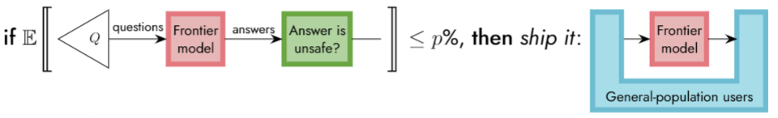
This is a diagram of an Eval model. It shows that if the percentage of Evaluations is less than or equal to 𝑝% then answers are deployed to general-population users. Within the Eval model, “questions” marked as 𝑄 are directed into a Frontier model marked in a box, which directs answers to an evaluator marked in box inscribed “Answer is unsafe?”. The threshold percentage of unsafe behaviours is indicated by ≤𝑝%, general population users are marked in a u-shaped box. This population feeds into and receives answers from the frontier model marked as a red box within the blue u-shaped box.

Limitations:
– One can obtain confidence that there is a safety problem by uncovering one in an eval, but if no problems are uncovered, this provides very little confidence about whether a safety problem could still emerge if a user employs alternative prompting strategies that are not represented in 𝑄.
– Users can invoke deployed models in complex recursive ways (“scaffolding”), which greatly expands the space of possible operating conditions that are not checked in an eval. Even if an advanced eval does test some scaffolds, the space of potential scaffolds is even more exponential than input strings.

+ Red-teaming, in which groups of highly skilled users of AI are tasked with evoking the most unsafe possible outputs from the model, and if they can’t find any problems, then the model can be deployed:

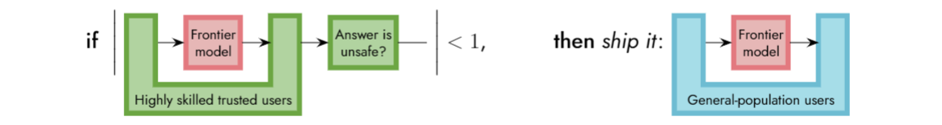
This is a diagram of a Red-teaming model. It shows that if the number of unsafe outputs are less than 1, the answers can be deployed to general population users. Within the Red-teaming model, “Highly skilled trusted users” are represented within a u-shaped box. These users direct the content into and receive answers from a “Frontier model” box that sits within the U. Answers are then directed to an evaluator marked in box inscribed “Answer is unsafe?”. The threshold number of unsafe outputs is indicated by “<1”, general population users are marked in a u-shaped box. This population feeds into and receives an answer from the “Frontier model” marked as a box within the u-shaped box.

Limitations:
– Since it involves in-depth interaction with humans, red-teaming is not very scalable.
– Although humans can exercise some ingenuity in surfacing problems, still, fundamentally, they cannot try everything, and the red-teaming exercise gives very little assurance of what the model might do outside the test coverage.

We would prefer a probabilistic guarantee that universally quantifies over an infinite family I of plausible initial conditions C of the deployment environment
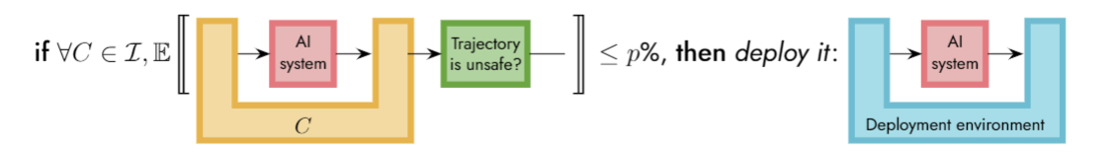
This is a diagram of a model depicting: if all initial conditions are the sum of an infinite family, and the percentage of Evaluations is less than or equal to 𝑝%, then answers are deployed to a deployment environment. Within the model the plausible initial conditions “C” are represented by a U-shaped box. These direct the content into and receive answers from an “AI system” box that sits within the U shape. Answers are then directed to an evaluator marked as “Trajectory is unsafe?” in a box. The threshold percentage of unsafe trajectories is indicated by ≤𝑝%, deployment environment is marked in a u-shaped box, this feeds into and receives answer from an AI system marked as a box within the u-shaped box.

However, very little R&D effort is currently going into approaches that provide quantitative safety guarantees about the deployment—even compared to AI safety as a whole—because this standard is commonly considered either impossible or impracticable: either it won’t work, or if it does work, it would take too long and not provide enough value, compared to direct use of frontier models.

One emerging but underexplored approach is the concept of a “gatekeeper” safeguard that formally verifies proof certificates which can be produced by a frontier model itself (with different fine-tuning and scaffolding).

A gatekeeper safeguard would have 3 distinct AI components each building on pre-trained frontier models:

1. frontier models adapted to iteratively construct an explainable, auditable, scientific mathematical model of the task-relevant aspects of the real world, and build on this to define quantitative specifications of safety criteria (as well as of task success);

2. frontier models adapted to use in-context learning to drive a proof search to prove certain probabilistic quantitative bounds (on the behaviour of certain cyber-physical systems when neural networks acting as autonomous AI systems are deployed into them), and produce proof certificates (which can be checked by a proof-checker that is itself formally verified); and

3. a variant of a deep reinforcement learning training loop which adapts (by fine-tuning, policy-gradient optimisation, pruning, distillation, low-rank decomposition, or otherwise) a powerful frontier AI model to become a neural network with high verifiability (to be verified by the previous method).

Figure 1: This gatekeeper approach can be seen as an overall workflow for safe deployments of AI.

[Pretraining process]
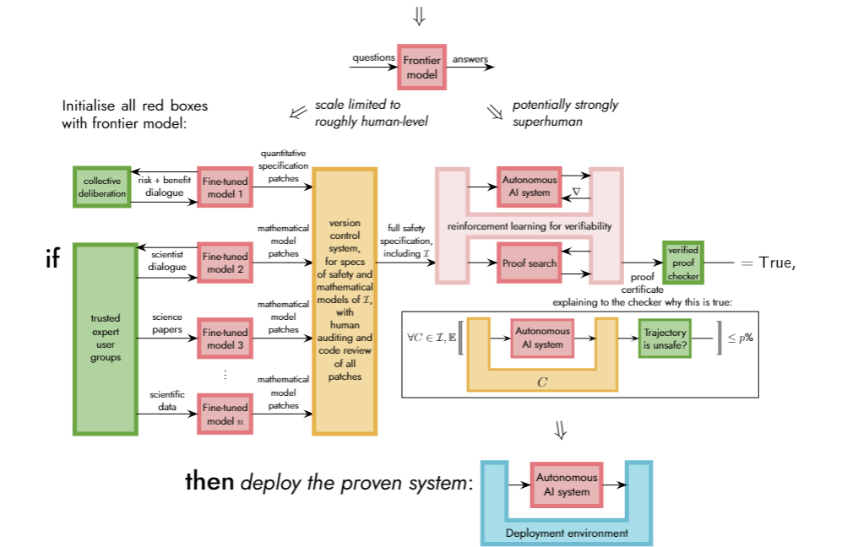

The goal of this programme is to demonstrate that a “gatekeeper” workflow like this can be a viable, universal solution for safeguarding many economically and socially valuable applications of AI.

We’ll do that by demonstrating the following:

TA1. That an extendable, interoperable language and platform can be built to maintain real-world models and specifications and check proof certificates.

TA2. That we can use frontier AI to help domain experts build best-in-class mathematical models of real-world complex dynamics with relevance to valuable applications, and leverage frontier AI to train autonomous systems that can be verified with reference to those models.

TA3. That a gatekeeper-safeguarded autonomous AI system deployed in a critical cyber-physical operating context can unlock significant economic value with quantitative safety guarantees. If we’re successful with any of these demonstrations, we believe this programme will be valuable.

If we succeed in all three, we believe we will have elucidated a viable and scalable path to safe transformative AI.

International collaboration
In line with the mission to ensure that AI systems are developed and deployed in service of humanity at large, we envision and seek to foster multilateral technical collaboration, both nationally and internationally, in order to drive progress, ensure interoperability and the sharing of safety-critical information, enable global deployment of Safeguarded AI workflows and avoid undue incentives to race ahead at the expense of safety. We hope, through this programme, to nucleate opportunities to develop such international collaborations, pioneered by the UK.

During the programme itself, we are exploring the following specific forms of collaboration, particularly with interested ATAS-exempt countries:
- Joint workshops: Researchers funded by this programme attending workshops hosted by international counterpart organisations, and vice versa.
- Extended visits to facilitate research collaborations between our programme and research funded by related programmes of partner agencies.
- Joint working groups: Researchers in TA1 with common interests across international efforts meeting regularly online and exchanging notes.
- Information-sharing arrangements: In TA2, where all research will be conducted in a single UK-based entity with strong security and oversight procedures, much research will not be public by default. However, we will encourage the TA2 organisation to form partnerships with international counterpart entities as they arise, particularly for sharing information that is important for the interoperability, compatibility, and joint safety of their systems.

We see our efforts towards the development of safe and beneficial AI as deeply complementary to the mission and work spearheaded by the UK’s AI Safety Institute (AISI). While AISI is focused on technical work that very directly informs governance and policy, ARIA’s focus is on fundamental research that has the potential to unlock novel safety and governance avenues in 3-10 years. We also plan to participate in informing AISI’s forward-looking analysis of “safety cases” for Safeguarded AI, and other proposed Guaranteed Safe AI methods. We believe all of these efforts are jointly needed to safely navigate the development and use of advanced AI capabilities throughout the next decade and beyond.

Aspirational theory of change
If we can catalyse a global scientific consensus that
+ there is a feasible R&D pathway which uses frontier AI systems only via assemblages that provide quantitative safety guarantees,
+ that one eventual application of these safety-critical assemblages is defending humanity against potential future rogue AIs[7,27] enough to reduce the risks to an acceptable level,
+ and that this milestone could be achieved, thereby making it safe to unleash the full potential of superhuman AI agents, within a time frame that is short enough (<15 years),
+ and with enough economic dividends along the way (>5% of unconstrained AI’s potential value)— then this would enable a new, cooperative Nash equilibrium in the global strategic landscape around frontier AI, enabling players to agree to follow this pathway (according to some plausible modelling assumptions; see Figure 2 and Appendix B).

Figure 2: In a simplified game-theoretic model of the choice that strategic players face (about whether to commit to a lengthy process of ending the acute risk period while using superhuman AI only inside systems with quantitative safety guarantees), the Nash equilibrium structure depends critically upon the required duration and the intermediate economic benefits (as a fraction of the net profit of unconstrained AI). See Appendix B for more details on these modelling assumptions.

The figure shows the “Current perception” has relatively high Years of R&D needed (30) and low economic competitiveness (3%) compared to the “Perception after a successful programme”, which has relatively lower years of R&D (13) needed and higher economic competitiveness (6%). An arrow is drawn from “Current Perception” to “Perception after a successful programme” labelled as “Opportunity”. “Reality after a successful programme” is marked as having relatively lower Years of R&D needed than both other points (10) and higher Economic competitiveness (20%). There are 3 coloured Ranges to describe cooperation desirability, Deadlock (cooperation is undesirable) is shown with the range of 25+ years of R&D needed and less than 26% Economic competitiveness. Prisoners Dilemma (Cooperation is desirable but irrational) is shown within the range of 14 - 25 years of R&D needed and 27 - 50% Economic competitiveness. Stag Hunt ( cooperation is a rational option) is shown as 14 years and below of R&D needed and 50+% Economic competitiveness. The Current perceptions falls within Deadlock, whilst Perception after a successful programme and Reality after a successful programme fall within Stag Hunt, indicating the growth in desirability of cooperation.

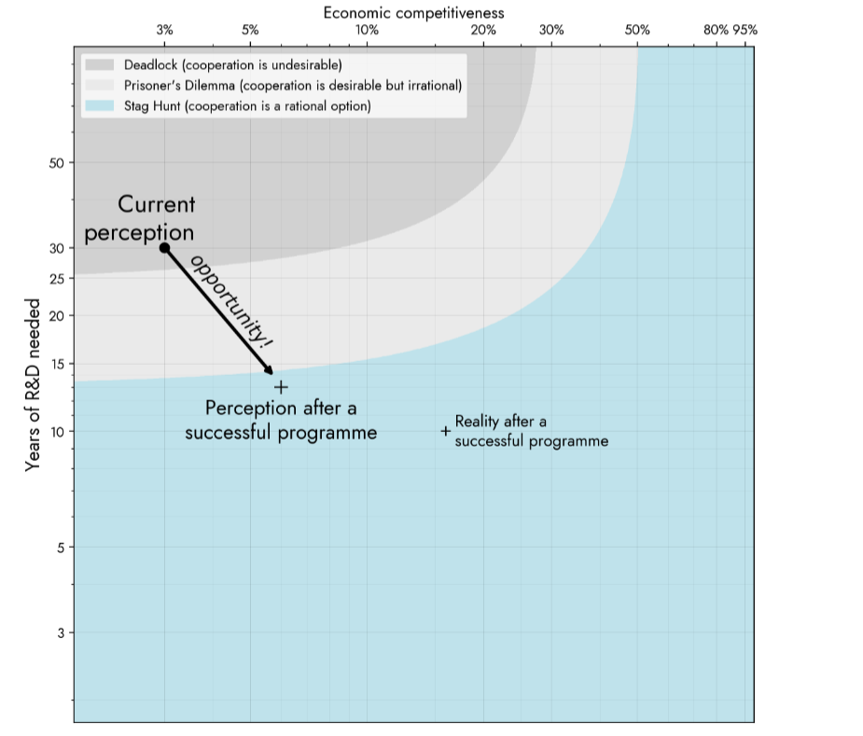

What we expect to fund
The programme is broken out into 3 technical areas (TAs), with the following names and top-level goals:

TA1 Scaffolding: Challenging the claim that “it’s not possible to formally specify what it means for a system to be safe in the real world” by demonstrating a tool that non-mathematician domain experts can use to develop and refine quantitative models and specifications about their systems of interest (e.g. power grids, epidemics, R&D roadmaps), with cross-domain interoperability (e.g. a lockdown changes the demand patterns on the power grid; a vaccine R&D process changes the epidemic). TA1 also includes a proof language and checker intended for AI systems to hook into to check if their outputs are verifiable (and iterate until they are).

TA2 Machine Learning: Challenging the claim that “even if it were possible to specify real-world safety, it wouldn’t be economically competitive to train an AI system that provably satisfies such a spec” by demonstrating empirically (albeit in simulation) a learned controller for a complex system of significance, that has verifiable quantitative probabilistic safety bounds, and achieves both better performance and better resilience to adverse events than non-certified baselines.

TA3 Applications: Challenging the claim that “even if you could train AI systems that provably satisfy their specs, no one would really use them, as the economy would only adopt mainstream AI instead” by demonstrating that the barriers to adoption in significantly valuable application domains can be overcome, leading to an organisation maintaining an actual production deployment in practice.

Technical Area 1 (TA1): Scaffolding

The primary requirement for a gatekeeper AI is to prove that an autonomous AI system satisfies its specification, such as a quantitative upper bound on the probability of significantly unsafe consequences of its actions.

In order to make such a proof, one must first define the specification with regard to the AI system; in order to define a specification of safety for an AI system operating as part of a real-world cyber-physical system, one must define a mathematical model of the dynamics of the environment and context into which the system is deployed. The specification can then make demands about what occurs in the environment (e.g. that some formally defined kind of “harm” does not take place with high probability), rather than formal specifications referring only to the relationship between inputs and outputs of the AI system itself (which is sufficient for defining some nontrivial properties, like “adversarial robustness”, but not any physical kind of safety). In order to be taken as “ground truth” about the bounds of what might occur in the deployment environment, to serve as a root of trust for the system’s certification, these mathematical models must be audited by teams of humans, and therefore the modelling language in which they are expressed must be both human-understandable and amenable to formal methods.

But this language cannot be hard-coded by humans, as the pioneers of good old-fashioned AI imagined. As Sutton put it in The Bitter Lesson[54] , “simple ways to think about…the arbitrary, intrinsically-complex, outside world…are not what should be built in, as their complexity is endless; instead we should build in only the meta-methods that can find and capture this arbitrary complexity.” As such, the goal of TA1 is not to develop an ontology (e.g. a list of the kinds of entities in the world and their possible relationships), but as much as possible, to develop a meta-ontology (e.g. the Semantic Web conceptual framework is a meta-ontology, and the framework of ordinary differential equations is a different meta-ontology) in which interoperable, compositional mathematical artefacts can be developed regarding all the causal pathways by which task-specific AI deployments may cause harm. We envision that these artefacts would be co-developed by human-level or near-human-level AI “copilots”, under the supervision of human domain experts, mediated by specialised human-computer interface paradigms designed for this purpose.

Mathematical models are the most fundamental type of artefact in TA1. A mathematical model has rigorous formal semantics that define a state space and a dynamics. At this level of foundations, we would like to transcend assumptions that the state space be finite, discrete, or even finite-dimensional; rather, we would like to constrain the state space only to be σ-compact (a countable union of compact spaces). For cross-domain interoperability, we would like our modelling language to be a common generalisation of many existing modelling languages (see Appendix A.1); and we would like our mathematical models to be constructed within a compositional “doctrine of dynamical systems” with flexible composition patterns[42] . In the same spirit of interoperability ARIA Copyright 2024 p. 5 / 19 between modelling frameworks, we would like to transcend assumptions that the dynamics be deterministic, stochastic, nondeterministic, graphical, or temporal; rather, we would like the basic concept of dynamics to be any rule that enables one to deduce information about some observables of the system trajectory from information about others, using an epistemic framework that encompasses both probabilistic (Bayesian) uncertainty and nondeterministic (Knightian) uncertainty within one monad1 .

Formal specifications are predicates about counterfactual probabilities about the distribution of trajectories in the state space. For example, a specification might require an upper-bound on the counterfactual probability of someone being harmed by an AI controller (under a resolution of unknowns in which they would not have been harmed if the AI did nothing):

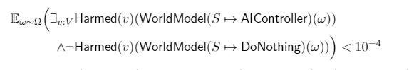
See also the work of Halpern et al. on quantifying harm [6], and on the minimax-weighted-expected-regret decision theory (MWER) [24]. The definition of state-space predicates (such as ‘Injured’) can be expressed in the same modelling language as state-space dynamics, but counterfactual queries, adversarial minimisation, regret calculations, and probabilistic bounds are additional logical primitives, which are likely best incorporated via an extended language for specifications.

Certificates are a quite broad concept, introduced by[38]: a certifying algorithm is defined as one that produces enough metadata about its answer that the answer’s correctness can be checked by an algorithm which is so simple that it is easy to understand and to formally verify by hand2. We are very interested in certificates, because we would like to rely on black-box advanced AI systems to do the hard work of searching for proofs of our desired properties, yet without compromising confidence that the proofs are correct. Since the feasibility of this is uncertain, in parallel, we are also exploring the incorporation of “certificates” which are traces of a randomised inference algorithm which is verifiably asymptotically correct or probably approximately correct [1,11]. Checking such a certificate amounts to checking that the randomness matches some verifiable random beacon, and that the trace is valid. In this programme, we are specifically interested in certificates of behavioural properties of cyber-physical systems (ranging from simple deterministic functions, to complex stochastic hybrid systems incorporating nuances like nondeterminism and partiality). To be a bit more specific, the properties of interest are typically universally quantified statements claiming that if some precondition A is true about a subsystem’s state trajectory x(t) at time t0, then the probability of some postcondition B being true at time t1 is bounded within a certain range:

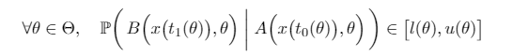

Some examples of kinds of certificates that could be useful in proving such quantitative bounds include barrier certificates [46], reach-avoid supermartingales [61], contraction metrics [55], Alethe certificates [4], LFSC proofs [53], branch-and-bound certificates [10], certificates based on abstract interpretation or bound propagation [8, 15], and Noetherian induction proofs [52]. Our goal in this programme’s proof certificate language is to unify as many of these approaches as possible3, to give an AI system maximum flexibility in constructing any sound and valid argument for its quantitative safety bounds.

Neural systems must be expressible in the modelling language, since the specifications we want to check will refer to variables which are to be filled in with neural networks, such as the ‘AIController’ variable in the example specification above. This is no problem for the theoretical semantics of the language because neural networks are semantically just continuous functions. However, it is a consideration for the data structures, algorithms, and interface formats, since neural networks tend to be very large, but typically have stereotyped compressible structure in terms of tensor algebra, of which we would of course want to take advantage. It may be useful to build on the ONNX format for the interchange of neural network architectures and weights [5] . We refer to “neural systems” to encompass a broader class of autonomous systems with neural-network components, but which may also include other algorithms4.

Programmatically, TA1 shall be divided into four technical subareas: TA1.1 Theory, TA1.2 Backend, TA1.3 Human-computer interface, and TA1.4 Sociotechnical integration, each of which (with the exception of TA1.4) covers the entire gamut of {models, specifications, certificates}, but from different perspectives, as follows.

TA1.1 Theory shall research and construct computationally practical mathematical representations and formal semantics for world-models, specifications, proofs, neural systems, and “version control” (incremental updates or patches) thereof.
TA1.2 Backend shall develop a professional-grade implementation of the Theory, yielding a distributed version control system for knowledge represented as mathematical world-models, as well as for specifications. The Backend shall also maintain a programmatic interface that can be used by AI-driven machine learning training loops to “check in” neural networks and verify proofs about them, with the backend producing counterexamples or informative error messages for invalid proofs. As a stretch goal, the Backend could also be responsible for “compiling” neural networks into a deployable executable package that has a high assurance of correctly implementing the exact mathematical function which was verified.
TA1.3 Human-computer interface shall develop a professional-grade user experience for eliciting formal explainable goals from stakeholders; auditing and editing scientific models; interactively collaborating with AI modelling assistants; reviewing proven guarantees and sample trajectories; red-teaming; developing new safety specifications in light of shortfalls; run-time monitoring of whether the incoming data is consistent with the mathematical model of the environment, especially the propositions claimed about it in a safety proof, to spot potentially safety-relevant anomalies; and any other aspects of the programme that are found to require human-computer interaction.
TA1.4 Sociotechnical integration shall develop and amend processes for diverse groups of stakeholders to make collective deliberations about acceptable risks and safety specifications, suggest quantitative bargaining solutions that could facilitate multi-objective certifiable ML, and make go/no-go decisions about any new deployment, release, or publication. This will use the quantitative safety guarantees computed in TA2, via the human-computer interfaces produced in TA1.3.

Technical Area 2 (TA2): Machine Learning:
Although the “gatekeeper” concept is intended to primarily build on mainstream pre-trained frontier AI models, it involves forking a frontier model and fine-tuning or “post-training” it in a few different ways in parallel, to assemble a workflow which transforms one final fork of the frontier model into a verifiably safeguarded AI system [5].
An advantage of our approach is that the satisfaction of specifications can be quantified with at least asymptotic correctness [6], but a substantial risk from developing a recipe for AI systems that certifiably behave in accordance with arbitrary specifications is that those specifications may not be adequately informed by all affected stakeholders. To mitigate this, we have also included sociotechnical control/oversight processes within the programme.
TA2 has four key objectives:

TA2(a) World-modelling ML shall fine-tune pre-trained (near-)human-level AI systems to convert human expressed language into a formal language that it can reason over, and vice versa; and to assist teams of human scientists and engineers in formally describing the operating environment and specifications for any given application(s). This could include fine-tuned models for:
- extracting structured data about physical parameters from spreadsheets [31], CAD drawings [60], unstructured chart images [25], and other formats;
- proposing ways to use this data to instantiate and populate a composition of probabilistic models, e.g. [58]
- applying probabilistic data cleaning techniques [36] to propose patches which make the data consistent and plausible
- extracting data from time-series measurements of a system in action, assisting in Bayesian updating on such data: e.g. by learning to approximate posteriors, by discovering compressed latent representations for data, by learning an amortised approximate likelihood, etc. [29,47]
- engaging in structured dialogue threads regarding model components (somewhat analogous to code review [44]), with humans or potentially with each other
- extracting mathematical models from scientific papers, e.g. [18]
- conjecturing (a distribution over) mathematical models from data alone, e.g. [51]
This objective corresponds to pursuing world-modelling levels W2–W4 in [12, fig. 2, sec. 3.2].
TA2(b) Coherent reasoning ML shall fine-tune frontier AI systems so that they can coherently reason about the pieces of knowledge in the world model. Exact reasoning may be intractable but can be approximated efficiently with methods such as amortised inference with neural networks, or by using neural networks to guide NP-complete algorithms which are only practical in combination with “good heuristics”. Either of these methods provide ways to leverage transformers and similar architectures to automate reasoning with reliable coherence, unlike purely end-to-end approaches which do not include explicit coherence constraints. This corresponds to verification level V6 in [12, fig. 4, sec. 3.4].
TA2(c) Safety guarantee ML shall fine-tune AI systems for verifying that a given action or plan is safe according to the given safety specification in a way that qualifies as a Guaranteed Safe AI method per [12]. This includes but is not limited to:
- combining the coherent-reasoning ML of TA2(b) with adversarial search for worst-case resolution of nondeterministic variables, which corresponds to verification level V7 in [12],
- amortised inference whose guarantees of correctly estimating desired conditional probabilities include practical nonasymptotic convergence bounds, i.e. verification level V8 in [12], or
- computing sound upper bounds on the probability of violating safety specifications, accompanied with some form of proof certificates7, which would correspond to verification level V9 in [12].
The primary purpose is to certify safety properties of cyber-physical systems with learned components, based on the given assumptions from the world-models output by TA2(a).
TA2(d) Policy Training shall develop general-purpose methods to train special-purpose policies that achieve domain-specific, finite-horizon safety guarantees while also achieving high performance in typical (i.e.“within-distribution”) situations, that can be independently certified via the capabilities developed in TA2(b,c). In particular, there should be a “backup” policy to switch to when safety verification of the high-performance policy fails, with stronger guarantees that the backup policy will satisfy the safety specification in a wider variety of situations (trading off task performance). During the scope of this programme, safety specifications should have a particular focus on harm that might be caused from within the system itself. Such systems might use, among others, methods such as:
- Runtime Verification (e.g. [39]): Instead of learning a single end-to-end neural network which is globally certified, the autonomous decision-making system which is certified could contain a version of a verifier (including one that relies on estimated probabilistic bounds of safety) that is fast enough to run in real-time8, which has different tradeoffs, and can be particularly advantageous when statically verifying all the possible cases would require exponential computation. Also, runtime verification is useful even if a single neural network is certified using static verification, because it would enhance overall sociotechnical robustness to use runtime verification techniques as runtime monitoring of functions of the sensor inputs and state estimates that play a role in the safety certificate, to proactively identify potential anomalies in which the true, real-world deployment environment diverges from what was modelled in an unexpected and potentially safety-relevant way.
- Probabilistic Shielding (e.g. [30, 59]): When a verifier has been designed, it can be used when training the policy so that actions that would be rejected by the verifier are not even considered in rollouts, making training of the policy more efficient.
- Counterexample-Guided RL for Static Verification (e.g. [32]): If the verifier produces specific examples9 where the specifications fail, these can be incorporated into a training loop as additional data samples, to augment the usual Monte Carlo rollout trajectories.

Figure 3: One way of visualising the topical breakdown of subareas in TA1 and TA2 is by considering kinds of artefact and methodology as orthogonal axes. Note that while most of the machine learning tasks in TA2 can be decoupled, the TA1 scaffoldings will overlap substantially. Size approximates estimated cost.

The figure displays “Methodology” on the vertical axis and “Kinds of Mathematical artefacts” on the horizontal axis. It indicates that TA1.4 utilises Social choice theory methodology with world-model specs and neural nets artefacts. TA2(a), 2(b), 2(c) and 2(d) use machine learning methodology with different artefacts, World model Specs for TA2(a), Neural nets for TA2(d) and certificates for TA2(b and c). TA1.3 uses Human computer user experience methodology with all 3 types of artefacts (World-model specs, Neural nets and certificates). TA1.2 uses Type checking Version control databases methodology with all 3 kinds of artefacts. TA1.1 uses Category theory with all 3 kinds of artefacts.


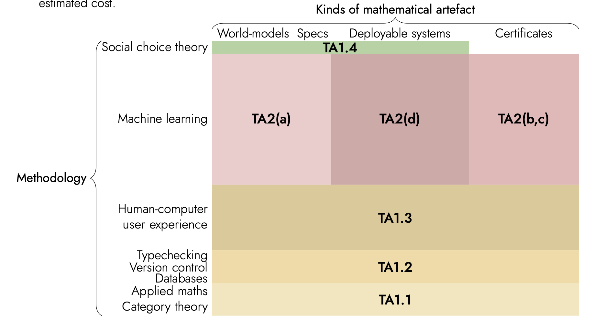

Figure 4: The interfaces between all technical subareas can be shown visually as horizontal contacts.
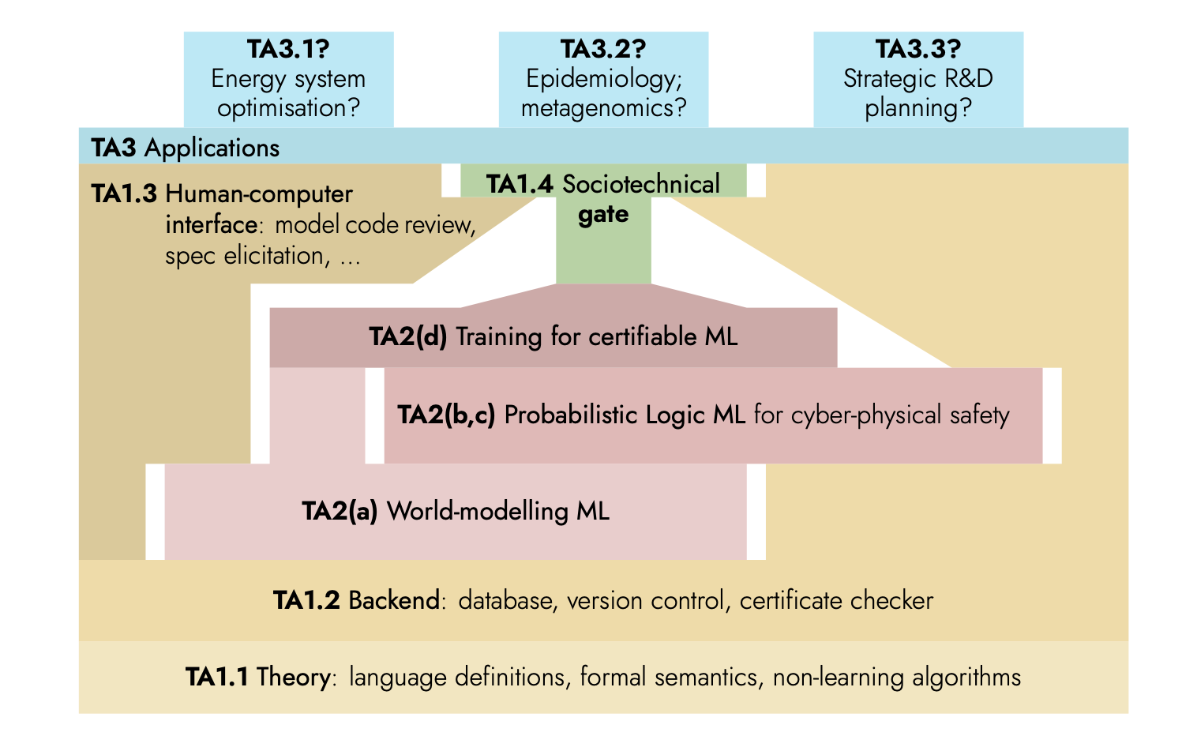

Technical Area 3 (TA3): Applications
Ultimately, it does not matter how safe a system is unless it is an acceptable substitute for less safe alternatives. TA3’s goal is to demonstrate that “gatekeeper AI” as a workflow can be used to create and maintain decision-support tools and/or autonomous AI systems that deliver value in practice for specific tasks. Programmatically, TA3 will likely consist of 2–4 full teams, each pursuing a different application area using the tools developed in the other TAs. An initial TA3 Phase 1 will cast a wider net, funding a larger number of part-time efforts
to elicit requirements in application areas and draft models and specifications by hand, in advance of the earliest prototypes being made available by other TAs.

Application areas suitable for an early demonstration (i.e. within our programme duration) likely fit these criteria:

(a) scalability— an ideal application area can offer a family of problems with “instances” at various scales of the size or number of entities being modelled, something like this:
+ with n1 it is almost trivial,
+ with n2 it is analytically tractable, but tricky,
+ with n3 it is already practically interesting, but routine for baseline methods,
+ with n4 it is pushing the limits of what seems practical today,
+ and if we could make it practical with n5, that would be a game-changer
(b) known in principle— the primary difficulties involved in this problem area should not include:
+ lack of a solid informal scientific consensus understanding of substantial aspects
+ difficulty of making sufficiently detailed measurements or observations of the phenomenon
Instead, the difficulties should be more like “there’s just a lot of moving parts”
or (less preferably) “it’s just really inefficient to compute”
(c) predictable in principle— not swamped by sensitivity to initial conditions
(d) need for high trust— because of their safety-critical or mission-critical nature, automation and AI
solutions for this application are currently facing serious barriers to adoption due to lack of reliability,
which our methods could directly address
(e) absence of bias or bias mitigation strategy— either we have data which is unaffected by systemic bias, and/or we have no reason to expect existing large language models distilled from internet text to bring in systemic bias, or we have a plan in place to avoid the default outcome in which these biases become encoded and amplified by the model [footnote 10]
(f) large-scale relevance—if humanity mastered automated control over this phenomenon at the larger scales, it could provide socioeconomic benefits on the scale of hundreds of millions of pounds per year
(g) existing baseline predictor or controller(s)— there’s some approximate and/or costly ways that
large instances are dealt with in practice today, to which new predictive mathematical models and
new decision-making systems could be quantitatively compared

The full set of specific applications is to be determined in the review of responses to the TA3 solicitation, but some areas we’re currently exploring include:
+ energy system optimisation, e.g.
+ real-time power dispatch to manage supply and demand and respond to perturbations
(especially complex with energy storage and more renewable supply)
+ probabilistic demand forecasting, on various time scales
+ keeping network models up-to-date (e.g. with new rooftop solar installations)
+ long-term planning of transmission network capacity improvements
+ telecommunications network optimisation
+ real-time allocation of beamforming subchannels to optimise transmitter energy consumption
+ management of upstream/backhaul capacity
+ long-term network expansion planning
+ supply chain and inventory management
+ probabilistic demand forecasting
+ distribution requirements planning
+ last-mile delivery routing
+ control systems for robots in human environments
+ medical device control systems
+ optimisation of clinical trials
+ infectious disease epidemiology
+ especially under various intervention scenarios, for decision support
+ incorporating diverse data sources, including metagenomics
+ climate and weather prediction
+ especially under various intervention scenarios
+ transport optimisation
+ aircraft and spacecraft flight dynamics
+ fully autonomous
+ autopilots
+ airspace/traffic control
+ R&D planning
+ roadmapping
+ short-term project management
+ medium-term forecasting
+ long-term R&D portfolio planning
+ complex business processes
+ data integration in contexts where it is usually done by hand to avoid mistakes

Figure 4: The Interfaces between all technical subareas can be shown visually as horizontal contacts, with TA3.1, TA 3.1, TA3.3 as separate columns along the top of TA3. TA1.3, 2.4, 2.3,2.2 and 2.1 below TA1.2 and TA1.1 at the bottom are displayed.

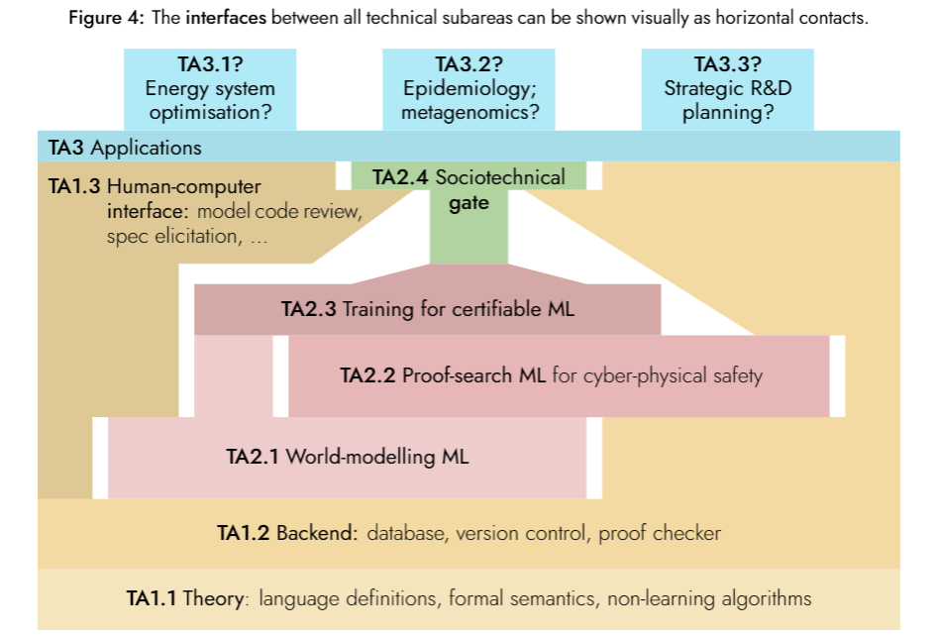

How we expect to fund
We anticipate staging funding opportunities in the following sequence:

TA1.1 Theory In this area we would fund researchers for one or two projects each that would be the initial hypothesis for what they would start working on, but we would hold this hypothesis lightly and assume that on a quarterly or even monthly cadence, it might make sense to change course and take on a different problem—or, having definitively solved a certain scoped question, then build on that solution to identify the shape of the next frontier.

We would suggest an initial list of problems (see Appendix A for an early draft), and would welcome proposals to tackle those problems head-on, but we are also open to suggestions of related but distinct theoretical problems.

We expect to have an ongoing collaboration and free flow of ideas between participants in TA1.1. In this area we would in large part evaluate success by how much participants have built on others’ work and how much others have built on their work, and in part by subjective review.

TA3 Applications (Phase 0) In this area we would solicit potential entrepreneurs or existing entities interested in using our gatekeeper AI workflow to build safeguarded products for specific tasks in a specific sector, with Phase 0 providing a small amount of funding to deeply understand customer needs and elicit requirements, begin to source datasets, design evaluation suites to validate the performance of predictive models and autonomous or semi-autonomous controllers, etc.

TA2 Machine learning (Phase 0) In this area we would plan to fund a major R&D effort within a single institution, ideally with the following characteristics:

+ Based in the United Kingdom

+ Co-funded by one or more partner organisations

+ World-class cybersecurity

+ Credible ability to source world-class talent in machine learning research & engineering

+ Decisions to publish algorithms, models, or code, or to release products or API access
externally, should be governed by a diverse board with the sole mission of ensuring that the expected benefits of AI to humanity and society substantially exceed the risks

+ Flexibility to pursue multilateral information-sharing and strategic partnerships with other private and/or government-sponsored entities— if and only if determined to align with the mission Such an institution could be a unit or subsidiary of an existing organisation, or it could be a newly formed entity. An early Phase 0 would fund initial explorations to put together a full proposal.

Success in TA2 would be evaluated by one or more groups in TA3 Applications, which would each be building benchmark metrics for performance in a specific application area, such as energy system optimisation, autonomous aircraft, R&D planning, dexterous manipulation, etc., with one area being selected for the initial scope of work

TA1.2 Backend In this area we would fund 1 or 2 software development organisations (with strong mathematics capabilities) to elicit concrete requirements from TA1.1 creators for implementation of their theory. If the requirements engineering process is successful, this would lead to a much larger award to build some or all of the backend software for the programme’s software platform (with success being evaluated according to those requirements

TA1.3 Human-computer interface In this area we would fund 1 or 2 software development organisations (with strong design/HCI/UX capabilities) to begin a collaborative process of shaping the requirements for interfaces that can help humans with diverse ways of thinking to interact with the systems being built in TA1.2 Backend and TA2.1 World-modelling ML. In this area, success would be evaluated by reviews from users across all areas of the programme.
TA1.4 In this area we will fund 2-4 teams from the social sciences in developing decision-making processes, tools and governance mechanisms for diverse groups of stakeholders with the goal of eliciting safety specifications, setting acceptable risk thresholds and providing accountability with respect to the development and application of AI decision support tools or autonomous control systems as envisioned here.
We anticipate that this will be a highly coordinated programme, with quarterly workshops to facilitate teams with interfaces (the horizontal contact surfaces shown in Figure 4) having opportunities to reach agreements about syntax and semantics of the formats of information that would flow through such interfaces. In advance of programme launch we will coordinate with the UK’s AI Safety Institute (AISI) to identify any potential areas of collaboration

Intellectual property will be managed differently in each TA:

TA1 work is to be carried out in public by default, with permissively licensed open-source code and documentation, no patents without a patent non-aggression pledge (example), and all publications available open-access. This is primarily to accelerate adoption and flow of ideas, but also because in the ultimate vision, the TA1 scaffolding is the platform for a global assurance mechanism that enables multiple actors to verify certificates from each other’s AI systems proving compliance with internationally agreed norms; the involvement of a patchwork of proprietary IP rights would complicate such usage.

TA2 work is to be done in a secure environment, with serious measures in place to avoid leaks of model weights (or even leaks of most concrete algorithmic ideas), for example to include strict NDAs, device policies, etc. Patents may be filed without a patent non-aggression pledge if the TA2 entity sees fit, but most patentable inventions in TA2 should more likely be protected as trade secrets. The TA2 entity should have a robust process in place to review and wisely evaluate potentially beneficial releases (publications, weights, API availability, commercial licensing—including to TA3 entities, etc.). This is because, if successful, TA2 work would substantially facilitate AI misuse in addition to reducing the risk of AI accidents [7] , so the outputs must be carefully governed to ensure a net-positive impact, which implies that in the first instance they must not proliferate irreversibly.

TA3 work, which consists of vertical-domain-specific models, libraries, techniques, and control systems constructed by TA3 creators using TA1 and TA2 software tools, can be treated in the ordinary way as the proprietary IP of its creators.

What we are still trying to figure out
+ What are the shortest critical paths for each subarea to get started, e.g. by using a preliminary version of each dependency, or by acting as an observer?
+ What are the best formats for high-bandwidth interactions to elicit requirements and establish interfaces and abstractions?
+ Will we attract strong enough participants within the UK—or to the UK—for TA2?

SOURCES
References cited in this document.
[1] Alon, Noga, Steve Hanneke, Ron Holzman and Shay Moran. A theory of PAC learnability of partial concept classes, 2021 IEEE 62nd annual symposium on foundations of computer science (FOCS), [13] IEEE, Feb. 2022, ᴅᴏI: 10.1109/focs52979.2021.00070, URL: http://dx.doi.org/10.1109/FOCS52979. 2021.00070 (cited on p. 8)

[2] Alvarez-Picallo, Mario, Dan R. Ghica, David Sprunger and Fabio Zanasi. Functorial string diagrams for reverse-mode automatic differentiation, 28th July 2021, arXiv: 2107.13433 (cited on p. 16)
[3] Amadini, Roberto, Graeme Gange, Peter Schachte, Harald Søndergaard and Peter J. Stuckey. Abstract interpretation, symbolic execution and constraints, Schloss Dagstuhl, 2020, ᴅᴏI: 10.4230/OASIcs.Gabbrielli.7 (cited on p. 17)
[4] Andreotti, Bruno, Hanna Lachnitt and Haniel Barbosa. Carcara: An efficient proof checker and elaborator for SMT proofs in the Alethe format, TACAS 2023, vol. 13393, LNCS, Springer, 2023, 367–86, ᴅᴏI: 10.1007/978-3-031-30823-9_19 (cited on pp. 6, 7)
[5] Bai, Junjie, Fang Lu, Ke Zhang et al. ONNX: Open neural network exchange, 2019, url: https://github.com/onnx/onnx (cited on p. 6)
[6] Beckers, Sander, Hana Chockler and Joseph Y. Halpern. Quantifying harm, 2022, arXiv: 209.15111 (cited on p. 8)
[7] Bengio, Yoshua. AI and catastrophic risk, Journal of Democracy 34.4 (Oct. 2023), 111–21, ᴅᴏI: 10.1353/jod.2023.a907692, url: https://www.journalofdemocracy.org/ai-and-catastrophic-risk/ (cited on pp. 1, 4, 12)
[8] Besson, Frédéric, Thomas Jensen and David Pichardie. A PCC architecture based on certified abstract interpretation, Research Report RR-5751, Inria, 2005, url: https://inria.hal.science/inria-00070268 (cited on pp. 6, 7)
[9] Boisseau, Guillaume, Chad Nester and Mario Román. Cornering optics, EPTCS 2023, vol. 380, 6, 2023, 97–110, ᴅᴏI: 10.4204/EPTCS.380.6, arXiv: 2205.00842 (cited on p. 16)
[10] Cheung, Kevin K. H., Ambros Gleixner and Daniel E. Steffy. Verifying integer programming results, IPCO 2017, vol. 10328, LNCS, Springer, 2017, 148–60, ᴅᴏI: 10.1007/978-3-319-59250-3_13, arXiv: 1611.08832 (cited on pp. 6, 7)
[11] Coregliano, Leonardo N. and Maryanthe Malliaris. High-arity PAC learning via exchangeability, 2024, arXiv: 2402.14294 (cited on p. 8)
[12] Dalrymple, David ”davidad”, Joar Skalse, Yoshua Bengio, Stuart Russell, Max Tegmark et al. Towards Guaranteed Safe AI: A framework for ensuring robust and reliable AI systems, 2024, arXiv: 2405.06624 (cited on pp. 1, 10)
[13] Dash, Swaraj, Younesse Kaddar, Hugo Paquet and Sam Staton. Affine monads and lazy structures for Bayesian programming, POPL 2023, vol. 7, ACM, Jan. 2023, 1338–68, ᴅᴏI: 10.1145/3571239, arXiv: 2212.07250 (cited on p. 16)
[14] Dawson, Charles, Sicun Gao and Chuchu Fan. Safe control with learned certificates: A survey of neural Lyapunov, barrier, and contraction methods for robotics and control, IEEE Transactions on Robotics 39.3 (June 2023), 1749–67, ᴅᴏI: 10.1109/tro.2022.3232542, arXiv: 2202.11762 (cited on p. 7)
[15] Desmartin, Remi, Omri Isac, Grant Passmore, Kathrin Stark, Ekaterina Komendantskaya and Guy Katz. Towards a certified proof checker for deep neural network verification, LOPSTR 2023, vol. 14330, LNCS, Springer, 16th Oct. 2023, 198–209, ᴅᴏI: 10.1007/978-3-031-45784-5_13, arXiv: 2307.06299 (cited on pp. 6, 7)
[16] Di Lavore, Elena and Mario Román. Evidential decision theory via partial Markov categories, LICS 2023, IEEE, 30th Jan. 2023, arXiv: 2301.12989 (cited on p. 17)
[17] Dokter, J. L. Analysis methods of hybrid systems applied to stochastically and dynamically colored Petri nets, Master’s Thesis in Applied Mathematics, University of Groningen, 10th May 2013, url: https://fse.studenttheses.ub.rug.nl/10947/1/Scriptie.pdf (cited on p. 16)
[18] Dunn, Alexander, John Dagdelen, Nicholas Walker, Sanghoon Lee, Andrew S. Rosen et al. Structured information extraction from complex scientific text with fine-tuned large language models, 10th Dec. 2022, arXiv: 2212.05238 (cited on p. 7)
[19] Edwards, Alec, Andrea Peruffo and Alessandro Abate. Fossil 2.0: Formal certificate synthesis for the verification and control of dynamical models, 16th Nov. 2023, arXiv: 2311.09793 (cited on p. 7)
[20] Everidj, M. H. C. and H. A. P. Blom. Hybrid state Petri nets which have the analysis power of stochastic hybrid systems and the formal verification power of automata, tech. rep. NLR-TP-2010-324, NLR Air Transport Safety Institute, Feb. 2010, url: https://reports.nlr.nl/server/api/core/bitstreams/167f434f-8a4a-4cb1-8a6f-17e41e72c659/content (cited on p. 16)
[21] Grandis, Marco. Higher dimensional categories: From double to multiple categories, World Scientific, Apr. 2019, ᴅᴏI: 10.1142/11406 (cited on p. 16)
[22] Gruetzemacher, Ross and Jess Whittlestone. The transformative potential of artificial intelligence, Futures 135 (Jan. 2022), 102884, ᴅᴏI: 10.1016/j.futures.2021.102884 (cited on p. 2)
[23] Hadzihasanovic, Amar and Diana Kessler. Higher-dimensional subdiagram matching, 18th Apr. 2023, arXiv: 2304.09216 (cited on p. 16)
[24] Halpern, Joseph Y. and Samantha Leung. Weighted sets of probabilities and minimaxweighted expected regret: new approaches for representing uncertainty and making decisions, 2012, arXiv: 1210.4853 (cited on p. 8)

[25] Han, Yucheng, Chi Zhang, Xin Chen, Xu Yang, Zhibin Wang et al. ChartLlama: A multimodal LLM for chart understanding and generation, 2023, arXiv: 2311.16483 (cited on p. 7)
[26] Hendrycks, Dan, Geoffrey Hinton, Yoshua Bengio, Demis Hassabis, Sam Altman et al. Statement on AI risk, 2023, url: https://www.safe.ai/statement-on-ai-risk (cited on p. 2) ARIA Copyright 2024 p.13/ 19ARIA CONFIDENTIAL – NOT FOR DISTRIBUTION
[27] Hendrycks, Dan, Mantas Mazeika and Thomas Woodside. An overview of catastrophic AI risks, 21st June 2023, arXiv: 2306.12001 (cited on pp. 1, 4)
[28] Hubinger, Evan, Carson Denison, Jesse Mu, Mike Lambert, Meg Tong et al. Sleeper agents: Training deceptive LLMs that persist through safety training, 10th Jan. 2024, arXiv: 2401.05566 (cited on p. 2)
[29] Jain, Moksh, Tristan Deleu, Jason Hartford, Cheng-Hao Liu, Alex Hernandez-Garcia and Yoshua Bengio. GFlowNets for AI-driven scientific discovery, Digital Discovery 2 (5th Apr. 2023), 557–77, ᴅᴏI: 10.1039/D3DD00002H, arXiv: 2302.00615 (cited on p. 7)
[30] Jansen, Nils, Bettina Könighofer, Sebastian Junges, Alexandru C. Serban and Roderick Bloem. Safe reinforcement learning via probabilistic shields, 16th July 2018, arXiv: 1807.06096 (cited on p. 8)
[31] Jia, Ran, Qiyu Li, Zihan Xu, Xiaoyuan Jin, Lun Du et al. SheetPT: Spreadsheet pre-training based on hierarchical attention network, AAAI 37.11 (June 2023), 12951–8, ᴅᴏI: 10.1609/aaai.v37i11.26522 (cited on p. 7)
[32] Jin, Peng, Jiaxu Tian, Dapeng Zhi, Xuejun Wen and Min Zhang. Trainify: A CEGAR-driven training and verification framework for safe deep reinforcement learning, CAV 2022, vol. 13371, LNCS, Springer, 2022, 193–218, ᴅᴏI: 10.1007/978-3-031-13185-1_10 (cited on p. 8)
[33] Kitagawa, Fuyuki, Takahiro Matsuda and Takashi Yamakawa. NIZK from SNARG, TCC 2020, vol. 12550, LNCS, Springer, 2020, 567–95, ᴅᴏI: 10.1007/978-3-030-64375-1_20 (cited on p. 7)
[34] Kosoy, Vanessa and Alexander Appel. Infra-Bayesian physicalism: A formal theory of naturalized induction, 1st Dec. 2021, ᴜRᴌ: https://www.alignmentforum.org/ posts/gHgs2e2J5azvGFatb/infra-bayesian- physicalism-a-formal-theory-of- naturalized (cited on pp. 6, 16)
[35] Landin, P. J. The next 700 programming languages, Communications of the ACM 9.3 (Mar. 1966), 157–66, ISSN: 1557-7317, ᴅᴏI: 10.1145/365230.365257, url: https://www.cs.cmu.edu/~crary/819-f09/Landin66.pdf (cited on p. 16)
[36] Lew, Alexander K., Monica Agrawal, David Sontag and Vikash K. Mansinghka. PClean: Bayesian data cleaning at scale with domain-specific probabilistic programming, (2020), arXiv: 2007.11838 (cited on p. 7)
[37] Master, Jade. Petri nets based on Lawvere theories, Mathematical Structures in Computer Science 30.7 (Aug. 2020), 833–64, ᴅᴏI: 10.1017/s0960129520000262 (cited on p. 16)
[38] McConnell, R.M., K. Mehlhorn, S. Näher and P. Schweitzer. Certifying algorithms, Computer Science Review 5.2 (May 2011), 119–61, ᴅᴏI: 10.1016/j.cosrev.2010.09.009, ᴜRᴌ: http://alg.cs.uni- kl.de/en/team/schweitzer/publikationen/docs/CertifyingAlgorithms.pdf (cited on p. 6)
[39] Mehmood, Usama, Sanaz Sheikhi, Stanley Bak, Scott A. Smolka and Scott D. Stoller. The black-box simplex architecture for runtime assurance of autonomous CPS, NASA Formal Methods Symposium 2022, vol. 13260, LNCS, Springer, 2022, 231–50, ᴅᴏI: 10.1007/978-3-031-06773-0_12, arXiv: 2102.12981 (cited on p. 8)
[40] Mio, Matteo, Ralph Sarkis and Valeria Vignudelli. Combining nondeterminism, probability, and termination: Equational and metric reasoning, LICS 2021, IEEE, June 2021, ᴅᴏI: 10.1109/lics52264.2021.9470717, arXiv: 2012.00382 (cited on pp. 6, 16)
[41] Moura, Leonardo de and Sebastian Ullrich. The Lean 4 theorem prover and programming language, CADE 2021, vol. 12699, LNCS, Springer, 2021, 625–35, ᴅᴏI: 10.1007/978-3-030-79876-5_37 (cited on p. 6)
[42] Myers, David Jaz. Categorical systems theory, 3rd Sept. 2023, ᴜRᴌ: http: //davidjaz.com/Papers/DynamicalBook.pdf, book draft (cited on pp. 5, 16)
[43] Myers, David Jaz. String diagrams for double categories and equipments, 2016, arXiv: 1612.02762 (cited on p. 16)
[44] Pascarella, Luca, Davide Spadini, Fabio Palomba, Magiel Bruntink and Alberto Bacchelli. Information needs in contemporary code review, Proceedings of the ACM on human-computer interaction 2.CSCW (Nov. 2018), 1–27, ᴅᴏI: 10.1145/3274404 (cited on p. 7)
[45] Patterson, Evan, Owen Lynch and James Fairbanks. Categorical data structures for technical computing, Compositionality 4.5 (2022), ᴅᴏI: 10.32408/compositionality-4-5, arXiv: 2106.04703 (cited on p. 16)
[46] Prajna, Stephen, Ali Jadbabaie and George J. Pappas. A framework for worst-case and stochastic safety verification using barrier certificates, IEEE Transactions on Automatic Control 52.8 (Aug. 2007), 1415–28, ᴅᴏI: 10.1109/tac.2007.902736 (cited on pp. 6, 7)
[47] Radev, Stefan T, Marvin Schmitt, Lukas Schumacher, Lasse Elsemüller, Valentin Pratz et al. Bayesflow: Amortized Bayesian workflows with neural networks, 2023, arXiv: 2306.16015 (cited on p. 7)
[48] Reutter, David and Jamie Vicary. High-level methods for homotopy construction in associative n-categories, 11th Feb. 2019, arXiv: 1902.03831 (cited on p. 16) ARIA Copyright 2024 p.14/ 19ARIA CONFIDENTIAL – NOT FOR DISTRIBUTION
[49] Schröer, Philipp, Kevin Batz, Benjamin Lucien Kaminski, Joost-Pieter Katoen and Christoph Matheja. A deductive verification infrastructure for probabilistic programs, OOPSLA 2023, ACM, Oct. 2023, ᴅᴏI: 10.1145/3622870, arXiv: 2309.07781 (cited on p. 17)
[50] Staton, Sam and Urs Schreiber. Convex powerset of distributions monad, nLab, 4th Dec. 2023, ᴜRᴌ: https://ncatlab.org/nlab/show/ Convex+powerset+of+distributions+monad (cited on p. 6)
[51] Stephany, Robert and Christopher Earls. PDE-READ: Human-readable partial differential equation discovery using deep learning, Neural Networks 154 (Oct. 2022), 360–82, ᴅᴏI: 10.1016/j.neunet.2022.07.008 (cited on p. 7)
[52] Stratulat, Sorin. Mechanically certifying formula-based Noetherian induction reasoning, Journal of Symbolic Computation 80 (May 2017), 209–49, ᴅᴏI: 10.1016/j.jsc.2016.07.014 (cited on pp. 6, 7)
[53] Stump, Aaron, Duckki Oe, Andrew Reynolds, Liana Hadarean and Cesare Tinelli. SMT proof checking using a logical framework, Formal Methods in System Design 42.1 (July 2012), 91–118, ᴅᴏI: 10.1007/s10703-012-0163-3, url: http://homepage.divms.uiowa.edu/ ~ajreynol/fmsd12.pdf (cited on pp. 6, 7)
[54] Sutton, Richard. The Bitter Lesson, 13th Mar. 2019, ᴜRᴌ: http://www.incompleteideas.net/IncIdeas/BitterLesson.html (cited on p. 5)
[55] Tsukamoto, Hiroyasu, Soon-Jo Chung and Jean-Jacques E. Slotine. Contraction theory for nonlinear stability analysis and learning-based control: A tutorial overview, Annual Reviews in Control 52 (2021), 135–69, ᴅᴏI: 10.1016/j.arcontrol.2021.10.001, arXiv: 2110.00675 (cited on p. 6)
[56] Wang, Xinyu, Luzia Knoedler, Frederik Baymler Mathiesen and Javier Alonso-Mora. Simultaneous synthesis and verification of neural control barrier functions through branch-and-bound verification-in-the-loop training, 2023, arXiv: 2311.10438 (cited on p. 6)
[57] Weitzman, Martin L. Gamma discounting, American Economic Review 91.1 (2001), 260–71 (cited on p. 23)
[58] Wong, Lionel, Gabriel Grand, Alexander K. Lew, Noah D. Goodman, Vikash K. Mansinghka et al. From word models to world models: Translating from natural language to the probabilistic language of thought, 2023, arXiv: 2306.12672 (cited on p. 10)
[59] Yang, Wen-Chi, Giuseppe Marra, Gavin Rens and Luc De Raedt. Safe reinforcement learning via probabilistic logic shields, 6th Mar. 2023, arXiv: 2303.03226 (cited on p. 11)
[60] Zhang, Shuming, Zhidong Guan, Hao Jiang, Tao Ning, Xiaodong Wang and Pingan Tan. Brep2seq: A dataset and hierarchical deep learning network for reconstruction and generation of computer-aided design models, Journal of Computational Design and Engineering (19th Jan. 2024), ᴅᴏI: 10.1093/jcde/qwae005 (cited on p. 9)
[61] Žikelić, Đorđe, Mathias Lechner, Thomas A. Henzinger and Krishnendu Chatterjee. Learning control policies for stochastic systems with reach-avoid guarantees, AAAI 2023 37.10 (June 2023), 11926–35, ᴅᴏI: 10.1609/aaai.v37i10.26407 (cited on pp. 8, 10)
[62] Žikelić, Đorđe, Mathias Lechner, Abhinav Verma, Krishnendu Chatterjee and Thomas A. Henzinger. Compositional policy learning in stochastic control systems with formal guarantees, 2023, arXiv: 2312.01456 (cited on pp. 8, 10)
[63] Zilberstein, Noam, Derek Dreyer and Alexandra Silva. Outcome logic: A unifying foundation for correctness and incorrectness reasoning, OOPSLA 2023, ACM, Oct. 2023 ᴅᴏI: 10.1145/3586045, ᴜRᴌ: https://www.cs.cornell.edu/~noamz/ files/pubs/outcome.pdf (cited on p. 20)

Appendix A Early draft of example questions to be answered in TA1.1
The following questions were developed in advance of this programme’s first workshop in December 2023.
- Compositional knowledge representation: Is there a natural framework, along the lines of ACSets[40], which incorporates schemas as “first-class citizens”, combines the power of relational and algebraic data types, and facilitates a generic notion of version control for changes to types and schemas (alongside incremental computation over data)?

- Unified diagram languages: What are the relationships between ACSets, multiple categories (in the sense of[17]), and various notions of string diagram (e.g. Zanasi et al’s hierarchical hypernets[1] , Hadzihasanovic’s higher-dimensional rewriting[19], Vicary’s associative n-categories[43], Myers’ string diagrams for double categories and equipments[38], Boisseau et al’s cornering diagrams[7], Master’s generalised Petri nets[32], etc.)?
+ In particular, can we build a natural “big tent” framework along the lines of “The Next 700 Programming Languages”[30] but for categorical systems diagram languages?

- Doctrines of stochastic hybrid systems: What is the natural construction of a dynamical systems Doctrine (in the sense of [37]) for open SDCPNs (stochasticdynamiccolouredPetrinets)[13], or equivalently (up to bisimilarity), GSHSs (general stochastic hybrid systems)[16]?
+ As a step in that direction, what about “open jump-drift-diffusion equations”?
+ Can we extend this to PDEs and SPDEs?

- Quantitative bounds: Can we build a “proof system” for establishing convex bounds on the probability distributions of certain variables in a hybrid system, where the proof can invoke abstractions and approximations that have certified error bounds?
+ Can we apply this to basis-theoretic discretisations of PDE solutions such as those used in numerical implementations?

- Epistemic conservatism: Probabilism is more conservative than determinism, but nondeterminism (sometimes called “possibilism”) and partiality (or “nontermination”) are distinct forms of epistemic conservatism that are not dominated by probabilism. The essential reason we cannot leave out nondeterminism is that not all spaces of possibilities that need to be considered come equipped with a probability measure, or even a canonical base measure like Lebesgue or Haar (with respect to which a uniform probability measure could be defined).
+ [35, Definition 36] introduced a monad that combines these three algebraic effects in a natural way [35, Theorem 38]. Much the same structure (non-empty topologically-closed ⊥-closed convex sets of sub probability distributions) was discovered independently in[29], motivated entirely by AI safety, under the almost-equally-unfortunate name “homogeneous ultracontributions”. Can we unify these, perhaps as non-empty topologically-compact ⊥-closed convex sets of subprobability measures?
+ Can we incorporate this more general semantics into our answers about compositional stochastic hybrid systems and quantitative bounds?

The group of participants at the workshop also generated several new questions, such as:

- Knowledge representation and version control via “path-dependent” types and a kind of finite types: can we construct a type theory in which instances of functional database schemas can be easily represented (by quantifying over finite types, which correspond to sets of row IDs), and which have a semantics in causal preorders, using a form of colimit completion to represent potentially-conflicting states of version-control of such data?

- Commutative monad of probability, nondeterminism, and partiality: regarding the final question above, these monads are not commutative, which is very inconvenient for probabilistic programming. Can we use “variable names” (along the lines of the countably infinite rose tree used to define Ω in[9]) to define a variant which is commutative, and additionally more closely resembles structural causal models?

- Functorial Boxes In Multiple Categories: is there a combinatorial recipe for constructing a multiple-categorical diagram language that bridges between different multiple categories (with certain multiple functors between them) by constructing all the “corner” (and “face”) generators?

- Double categories for branch-and-bound reasoning: can we add a multiple-categorical “dimension” toa monoidal category to track relational inclusions( like bicategories of relations but with metric/quantale structure) and use this to define branch-and-bound certificates as double-categorical diagrams?

- Hybrid doctrines of systems and specification theories: can we use fibrational methods to simultaneously define specifications and systems, and develop generic constructions of “hybrid systems” (one type of system fibred over the other), to easily hybridise many different modelling languages?

- Outcome logic in partial Markov categories[12]: what kind of outcome logic[58] or probabilistic verification logic (e.g. [44]) is the best suited? could this be a good semantics for abstract states (in the sense of abstract interpretation[2])?

- Global safety from local safety: can we use a Grothendieck construction to construct global safety proofs in a composite system from safety proofs of the components? is this related to rely/guarantee?

Appendix A.1 Initial list of modelling languages we would like to unify
- Differential equations
(a) ordinary (ODEs)
(b) partial (PDEs)
(c) stochastic (SDEs, SPDEs)
(d) random (RODEs, RPDEs)
(e) jump-diffusion
- Markov processes
(a) discrete-time Markov chains (DTMCs)
(b) continuous-time Markov chains (CTMCs)
(c) Markov decision processes (MDPs)
(d) Markov automata (MA)
(e) open games
(f) (open?) mean-field games
- Hybrid systems
(a) Generalised stochastic hybrid systems (GSHS)
- Petri nets (PNs)
- Probabilistic models
(a) probabilistic graphical models (PGMs)
i. Bayesian networks (BNs)
ii. structural causal models (SCMs)
iii. Markov random fields (MRFs)
(b) corecursive programs in a functional probabilistic programming language (PPL)
+ including, notably, autoregressive large language models (LLMs)
(c) probabilistic logic programs (ProbLog)
(d) score-based generative models (SBGMs)
+ including, notably, diffusion models

Appendix B Game theory analysis — modelling assumptions
The crucial considerations regarding the balance of accident risks against misuse risks and economic opportunity costs in a strategic setting already appear (in terms of Nash equilibrium structure) in the simplest possible game-theoretic framework, a 2-player normal-form symmetric bimatrix of payoff utilities for two strategies (”Saf” and ”Main”):

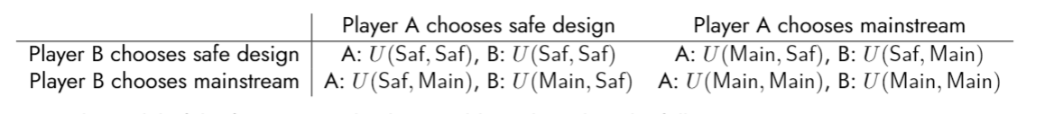

A simple model of the four expected utility variables is based on the following assumptions:
1. Ultimately, there are eight possible unmixed outcomes, spanned by the 3 binary variables
{LoseRace,WinRace} × {SafeDesign,Mainstream} × {Accident,Aligned}
2. Accident is a Bernoulli random variable whose probability is reduced by SafeDesign:
P(Accident|SafeDesign) <P(Accident|Mainstream)
3. For simplicity, we assume that there are values 0 <α≤ 1, 0 <β≤ 1, such that
U(SafeDesign ∧ · · · ) = α· U(Mainstream ∧ · · · ) + (1 − α) · U(Accident)
(i.e. αis the fraction of Mainstream economic value/utility that can still be gained via SafeDesign), and
U(LoseRace ∧ Mainstream ∧ Aligned) = β· U(WinRace ∧ Mainstream ∧ Aligned)
(i.e. βis the fraction of value that is retained even if one loses the race to an unleashed opponent).
4. Because SafeDesign methods should be used to end the acute risk period as soon as possible, the economic loss α(from restricting scaling to only SafeDesign systems) is only during an initial period of T years, when economic returns are a factor of α0 less, accounted for with an annual discount factor of γ:


We use the US FEDFUNDS rate at time of writing (5.33%) to set the default discount factor, γ= 1/(1 + 5.33%), to reflect the time-preference of large-scale capital flows.
5. Because a SafeDesign (in our vision/definition) would be multilateralist, we assume U(LoseRace ∧ SafeDesign) ≥ 99% · U(WinRace ∧ SafeDesign)
6. If both players have the same strategy, WinRace will be 50%.
7. P(WinRace|Saf,Main) is very low, but if this event takes place, it implies a SafeDesign:
WinRace ∧ (Saf,Main) ⇒ SafeDesign
8. If A and B both play Saf, then the outcome will be a SafeDesign.
(Saf,Saf) ⇒ SafeDesign
9. In case of Accident, WinRace or LoseRace, SafeDesign or Mainstream... don’t matter.
10.Without loss of generality (since utilities are invariant under affine transformation), we let
U(Accident) = 0
U(WinRace ∧ Aligned ∧ Mainstream) = 1

For the purposes of Figure 2 we have selected the following parameters:
(“minimally confident”, per Wasserstein¹¹)

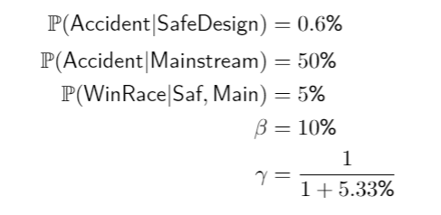

The remaining parameters of the model (α0 and T) are the x and y axes of Figure 2, respectively.

At the specific point marked “Reality after a successful programme”, we have T= 10 years and α0 = 16.9%, which implies α≈ 66%. This yields the outcome payoffs:

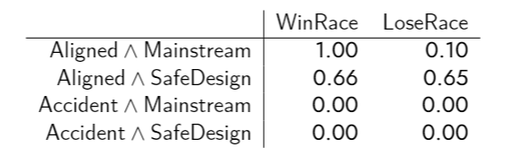
and the expected utility variable values:

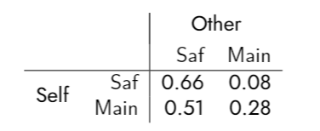
Figure 5: The sensitivity of the expected utility variables at (α0 = 16.6%, T= 10 years) to
P(Accident|Mainstream), at a “distant future” discount rate of γ= 1/(1 + 1%) [52]. The structure of the bimatrix game changes where the payoff lines cross, from Prisoner’s Dilemma at the left to Stag Hunt in the middle to No Conflict at the extreme right.

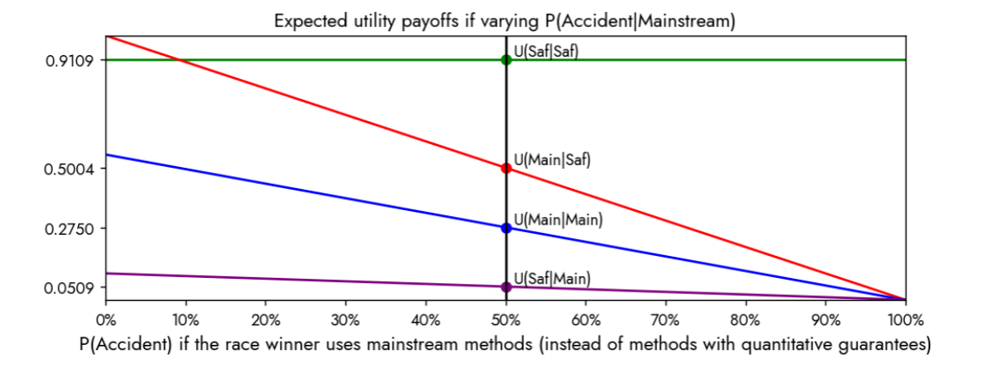

10. Even with a fully explainable and transparent model, there will be free parameters, and if applied to an area such as the dynamics of crime or social outcomes, both the parameters and the overall structure of the model can encode bias in hard-to-notice ways.
11. It is a common mistake to implicitly assume a privileged reference measure μon a set like {Accident,Aligned}, which is also ecessary to argue from “maximum entropy” or “minimum information” that one should privilege a probability measure ν, like so: ν=arg min_{ν}D_{KL}(ν|μ)=arg minν=arg min_{ν}DKL(ν|μ)=arg min_{ν} ∫Ωdν(ω)log (dν dμ(ω)) Counting measure can be justified by permutation-invariance, but there is no reason to assume that a set like this is permutation-invariant. However, if we have a pseudometric on the outcome space Ω, we can instead argue for the Wasserstein barycenter as the “least confident” measure, ν=arg min_{ν}arg max_{μ}W₁(ν,μ) Given a utility function U:Ω→R, we do indeed have a pseudometric on Ω={Accident,Aligned}, namely d(x,y)=|U(x)−U(y)|, and it can be shown that the “least confident” Wasserstein barycenter puts 50% probability mass on each of {Accident,Aligned}.∫Ω dν(ω)log (dν dμ(ω) )

